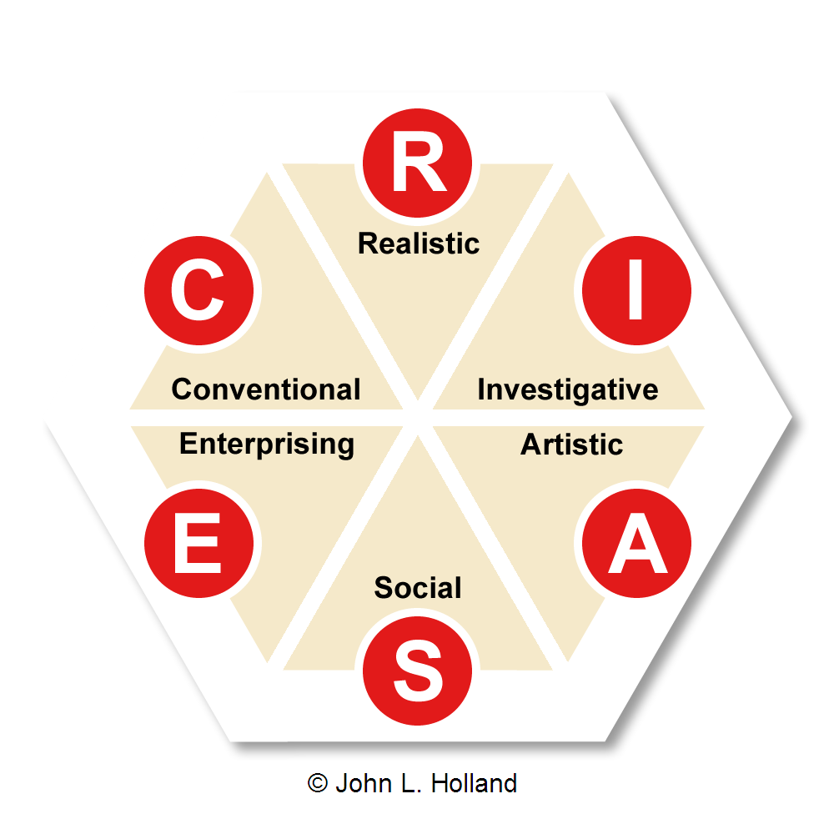
Holland’s theory of career choice
John Holland’s theory centres on the notion that most people fit into one of six personality types:
- realistic,
- investigative,
- artistic,
- social,
- enterprising, and
- conventional.

Realistic
Interest area:  You like working mainly with your hands making, fixing, assembling or building things, using and operating equipment, tools or machines.  You often like to work outdoors. | Key skills:  Using and operating tools, equipment and machinery, designing, building, repairing, maintaining, measuring, working in detail, driving, moving, caring for animals, working with plants. | Occupations with practical components:  Pilot, farmer, horticulturist, builder, engineer, armed services personnel, mechanic, upholsterer, electrician, computer technologist, park ranger, sportsperson. | Subjects to develop  your skills:  English, Maths, Science, Workshop, Technology, Computing, Business Studies, Agriculture, Horticulture, Physical Education.

Investigative
Interest area:  You like to discover and research ideas, observe, investigate and experiment, ask questions and solve questions. | Key skills:  Thinking analytically and logically, computing, communicating by writing and speaking, designing, formulating, calculating, diagnosing, experimenting, investigating. | Occupations with practical components:  Science, research, medical and health occupations, chemist, marine scientist, forestry technician, medical or agricultural laboratory technician, zoologist, dentist, GP. | Subjects to develop  your skills:  English, Maths, Science, Computing, Technology.

Artistic
Interest area:  You like using words, art, music or drama to express yourself, communicate or perform or you like to create or design things. | Key skills:  Expressing artistically or physically, communicating by speaking, writing and singing, performing, designing, presenting, planning, composing, playing, dancing. | Occupations with practical components:  Artist, illustrator, photographer, signwriter , composer, singer, instrument player, dancer, actor, reporter, writer, editor, hairdresser, fashion designer. | Subjects to develop  your skills:  English, Social Studies, Music, Drama, Art, Graphic Design, Computing, Business Studies, Languages.

Social
Interest area:  You like working with people to teach, train, inform, help, treat, heal, cure, serve and greet.  You are concerned for others’ well-being and welfare. | Key skills:  Communicating by writing and speaking, caring and supporting, training, meeting, greeting, assisting, teaching, informing, interviewing, coaching. | Occupations with practical components:  Teacher, nurse, counsellor, police officer, social worker, salesperson, customer secretary, service officer, waiter. | Subjects to develop  your skills:  English, Social Studies, Maths, Science, Health, Physical Education, Art, Computing, Business Studies, Languages.

Enterprising
Interest area:  You like meeting people, leading, talking to and influencing others, encouraging others, working in business. | Key skills:  Selling, promoting and persuading, developing ideas, public speaking, managing, organising, leading and captaining, computing, planning. | Occupations with practical components:  Salesperson, lawyer, politician, accountant, business owner, executive or manager, travel agent, music or sports promoter. | Subjects to develop  your skills:  English, Maths, Business Studies, Accounting, Economics, Social Studies, Drama, Computing, Languages.

Conventional
Interest area:  You like working indoors and at tasks that involve organising and being accurate, following procedures, working with data or numbers, planning work and events. | Key skills:  Computing and keyboarding, recording and keeping records, paying attention to detail, meeting and greeting, doing calculations, handling money, organising, arranging, working independently. | Occupations with practical components:  Secretary, receptionist, office worker, librarian, bank clerk, computer operator, stores and dispatch clerk. | Subjects to develop  your skills:  English, Maths, Business Studies, Accounting, Economics, Computing.

