Support for tertiary education learners who are disabled, neurodiverse or need learning support

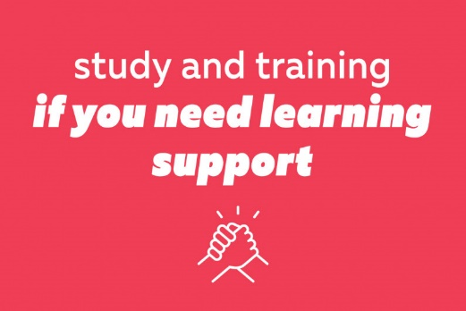

Published: January 2024

About this document
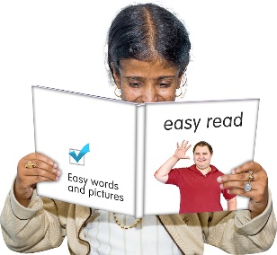

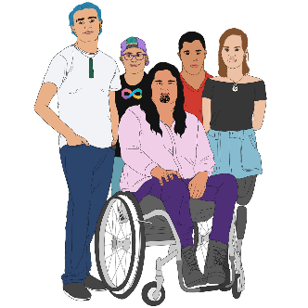
This Easy Read document is about what educational support is available for people who:
are disabled
are neurodiverse
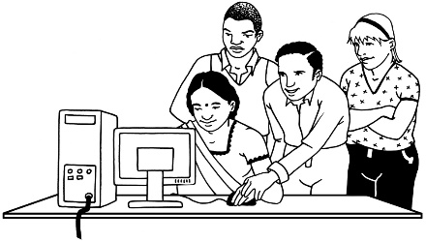
need extra learning support for any reason.

Neurodiverse people have brains that work in different ways.

They may have conditions like:
- Autism
- Attention Deficit Hyperactivity Disorder / ADHD.
There is a lot of support available:
when you are
studying / training
for as long as you are
studying / training.

Working with your school
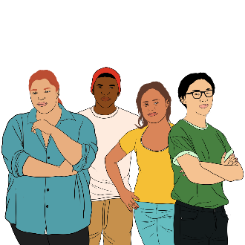

When you turn 14 years old your school should be assisting you in making a plan.

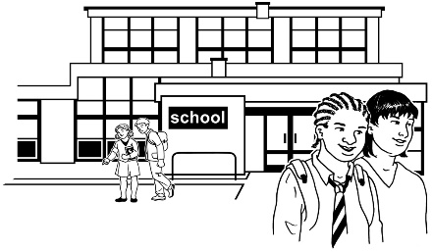
The plan will show how the school will help you with your extra learning needs.

More information on how your school can help you is available on the:
Ministry of Education website:
https://tinyurl.com/yvjmbj9b

CCS Disability Action website:
https://tinyurl.com/4dzs627c

Choosing an education provider

It is important to choose an education provider that understand / supports your learning needs if you want to do:
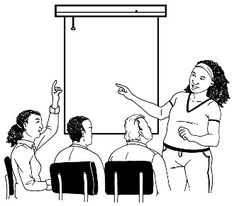
- tertiary study
- training.

Tertiary study / education is education that is done after school like in:
universities
polytechnics.

You can contact the student support team at your education provider to talk about what kind of support you need.
Most education providers have staff have support services for students who have:
sensory needs like being blind
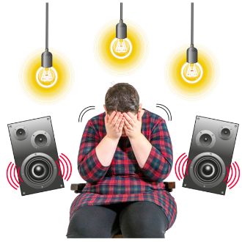
learning needs
mental health conditions
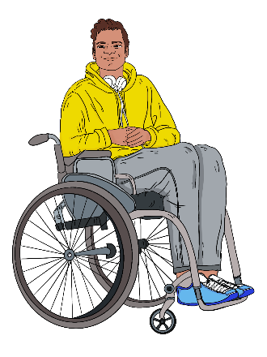
medical conditions
physical disabilities like needing a wheelchair
injuries.

These support services may include:
giving you advice
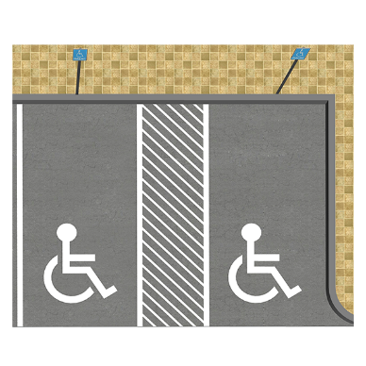
free accessible software
space for studying / meetings
assisting with access around:
- the place you are learning
- parking
sign language interpreters
providing information in different formats for you like Easy Read
letting you borrow equipment.

Software is a program that runs on your computer.

Equipment is the things needed to do something like a computer.
These support services may include people to support you in:
- the library
- laboratories which are the places you do science
- field work – work you do outside of campus
- taking notes.
These support services may include people to support you with doing:
- exams / tests
- assignments which are different ways of seeing how much you have learnt.

Work based learning

If you have learning support needs you can still:
have an apprenticeship
do a traineeship
learn while working in other ways.

An apprenticeship is when you:
learn a trade like building while you work
get paid for the work.

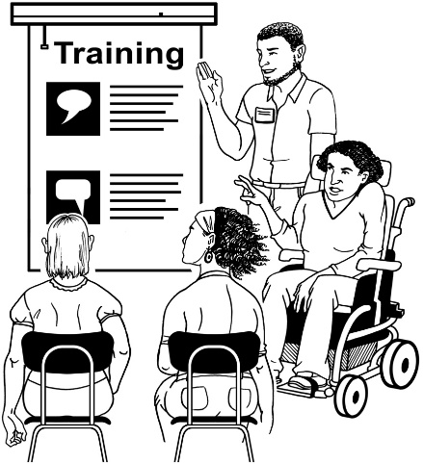
A traineeship is another way of learning while you work.

Traineeships are shorter than apprenticeships.

Some examples of people with learning support needs working in Aotearoa New Zealand are:
Deaf people working as:
- builders
- truck drivers
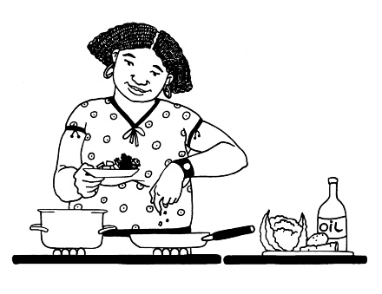
people with dyslexia working as:
- chefs
- hairdressers
farmers using quad bikes.

Useful links

Below are some website links to useful information.

This information at these website links is not in Easy Read.

You can ask someone you know for support to understand the information at these website links.

- Information about how to pay for your study / training is available on the Careers website here:
https://tinyurl.com/4u3w683v

- Information about disability support in school is available on the Ministry of Education website here:

https://tinyurl.com/2558hd7z

- Information about study / training options is available on the Careers website here:

https://tinyurl.com/2z7bnjz9

This information has been written by the New Zealand Government.

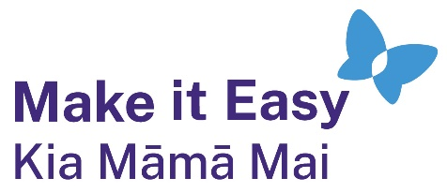
It has been translated into Easy Read by the Make it Easy Kia Māmā Mai service of People First New Zealand Ngā Tāngata Tuatahi.
The ideas in this document are not the ideas of People First New Zealand Ngā Tāngata Tuatahi.

Make it Easy uses images from:

- Changepeople.org

            - Photosymbols.com

- SGC Image Works
- Huriana Kopeke-Te Aho
- T. Wood.
All images used in this Easy Read document are subject to copyright rules and cannot be used without permission.

