Career
education
in practice



August 2009

Notes on editions
This is the second edition of this handbook. We have updated it to include learnings and evaluation findings from the Creating Pathways and Building Lives project (CPaBL), 2007-2008. It also includes a new part that outlines the aims, approaches and outcomes of that project.

We intend this handbook to be a living, evolving resource that we will grow and mature in the years to come. We hope you will help us do this by sending us your comments on this edition and contributing approaches and experiences that we can add to future editions. You can pass on your feedback to any Careers New Zealand career consultant or to the publications team.
freephone: 0800 222 733, email: careers@careers.govt.nz

Second edition © Careers New Zealand, 2009
First edition © Careers New Zealand, 2007
Permission is granted to reproduce this document in whole or part for non-commercial career education purposes, as long as the source is acknowledged.
Except as permitted under the Copyright Act 1994 or any copyright licence, no part of this document may be reproduced for other purposes without the prior permission of the publisher.

Published by Careers New Zealand, PO Box 9446, Wellington, New Zealand, (04) 8015177, careers@careers.govt.nz

This handbook is available as a downloadable file from the Careers New Zealand website, www.careers.govt.nz. To locate this handbook use the search box on the homepage.

Contents

What you will find in this handbook 2
Definitions 2
The big picture 3
Quality in career education 3
Effective transitions 4
Part 1 : Making it happen 5
Leadership 6
Planning and review 8
Design and evaluation 12
Management and delivery 16
Relationships 22
Part 2 : Learning and career planning 29
Part 3 : CPaBL project 38
References 40
Appendices 41
Appendix 1 : Common themes by year level 42
Appendix 2 : For first-time careers advisers 43
Appendix 3 : Example question areas for surveys 45
Appendix 4 : Checklists for planning and review 47

What you will find in this handbook

This handbook is intended as a practical tool to assist schools to manage and develop their career education programmes. It brings together findings from research with practical ideas and approaches being used in schools.
The handbook is designed to be used alongside Career Education and Guidance in New Zealand Schools (Ministry of Education, 2009, http://nzcurriculum.tki.org.nz/Careers). It is written for careers lead teams and careers advisers in secondary schools. For information on career education in primary and intermediate schools see the guide Understanding Career Education in Years 7 and 8 (Career Services, 2008).
The handbook aims to present information in ways that both experienced and new careers staff will find useful. For new careers staff or staff in schools with little experience of career education, there is a brief orientation to the role in Appendix 2.
The first part of the handbook presents information and suggestions related to career education management that could be useful in a wide range of school contexts. The second and third parts look at the key strands of two well resourced evaluated career education programmes:
  - Designing Careers (2005-2006) and
  - Creating Pathways and Building Lives (2007-2008).
The content in this handbook was developed through research and discussions with careers advisers across New Zealand. It uses the evaluation reports from the Designing Careers and Creating Pathways and Building Lives projects as key sources. Our thanks to the Education Review Office and the Ministry of Education for giving us permission to use this material.

Definitions
These definitions are from Career Education and Guidance in New Zealand Schools (2009)

A career is the sequence and variety of work roles, paid and unpaid, that a person undertakes throughout a lifetime. More broadly, ‘career’ embraces life roles in the home and the community, leisure activities, learning and work. Work, learning and life, though sometimes distinct, are closely intertwined. Everyone has a career.
Career education consists of planned, progressive learning experiences that help students develop career management competencies that will assist them to manage their lives. Career education includes elements that stand alone and elements that are part of regular classroom teaching.
Career guidance provides individualised interactions to help students move from a general understanding of life and work to a specific understanding of the life, learning and work options that are open to them. It helps individuals or small groups to better understand themselves and their needs, confront challenges, resolve conflicts, develop new perspectives and make progress. Career guidance is carried out by staff with specialist training. This may include deans and teachers providing pastoral care.
Career management competencies are the understandings, skills and attitudes that people use to develop and manage their careers. Career management competencies equip people to better understand themselves, make informed decisions about learning and work options, act on their decisions and participate effectively in work and society.

The big picture
Young people should be actively engaged in creating their own unique plans for their life, learning and work post-school, and actively developing the career management skills that they will need to make and remake their plans throughout life. This chapter summarises research findings on the contribution of career education in schools to young people successfully developing careers.

The Organisation of Economic Co-operation and Development (2000) finds that career education and guidance needs to reach young people as soon as possible to help them make successful transitions to further learning and work.
This view is supported in an international review of career education and guidance in schools across 36 countries (Watts & Sultana, 2003) that finds “there is growing recognition of the importance of career education and guidance in schools, not only in helping young people to make the immediate choices that confront them, but also in laying the foundations for lifelong learning and lifelong career development.”
This review also finds:
  - “there is a risk of career education and guidance being marginalised within the broad concept of guidance
  - alongside career education and guidance within the school itself, there is merit in making career guidance in a specialist form available from the employment service or some other agency based outside the school.”

Quality in career education
This continuum of quality in career education and guidance is adapted from Watts (2006). Schools may be at different points in the continuum for different groups of students.

Stage 1
We provide career information for our students but we do not have the time or resources to offer much support.
We leave it up to students to pick up the information. We hope they understand it and can relate it to their own situations.
Stage 2
We support our students through interviews and sometimes psychometric tests, but often there is too little time to ‘diagnose’ attributes and potential. Sometimes we have limited knowledge about available pathways.
We facilitate students to make their own career decisions, rather than giving ‘expert’ advice.
Stage 3
We support students through interviews and include career education in curriculum areas and in form time. We give students real experiences of work and tertiary study.
We try to get our students to construct rather than choose a career.
Stage 4
We do all of the above and involve families and whānau, as they have a strong influence on their children’s decisions.
We make contact with and encourage support from the community, employers, former students and other mentors. This involves more time and resources, but the payoffs in achieving our goals are worth it.

Effective transitions
Transition to secondary school

A study into the factors that facilitate or hinder students’ transitions from year 8 to year 9 (Ministry of Education, 2008) suggests that schools need to:
  - think of transition as a process not an event
  - provide ongoing deeper-level support for students to make adjustments over quite some time.
These suggestions are based on findings that:
  - most students adapt readily to the immediate changes of a new school and its systems, and have sound or good achievement gains at the end of year 9
  - at the same time this is a significant period of deeper-level change and can be unsettling for students. An important minority of students find it emotionally challenging
  - the second half of year 9 is the time when students are more likely to be more negative about school, relationships with teachers and teaching and learning in general.
The Competent Children, Competent Learners study investigated the effect of transition on student outcomes at age 16 (Ministry of Education, 2009). It concludes that “the transition to secondary school in New Zealand is currently not a major issue for many students.”
It suggests that the key factors in students making the most of the transition may be their “existing confidence in school work and life, and a belief that school matters.”

Transition from secondary school

Research by the New Zealand Council of Educational Research (2006), which looked at transition education programmes in seven decile 1 to 3 schools, finds that effective transition support is “embedded into the fabric of programmes of study” which:
  - offer a curriculum relevant to students’ interests
  - use student-centred pedagogy to build relationships
  - provide access to career and transition information, advice and support
  - provide ‘real’ experiences and opportunities to explore a range of options
  - develop effective bridges between school and the tertiary environment
  - allow students to gain qualifications, preferably with a recognised pathway
  - develop life skills.
It also notes that an emphasis on ‘next-step’ assistance at school may not be sufficient to support students through the changes of direction some will make post-school.
The Competent Children, Competent Learners study into student outcomes at age 16 (Ministry of Education, 2009) investigated how participants saw their lives unfolding in their first year of leaving school.
It finds that students still hold some traditional ideas about the concept of ‘career’ and suggests that “the new New Zealand Curriculum may help address this problem by shifting the way we think about knowledge, teaching and learning. For example, there may be potential for career decision-making skills to be taught through the key competencies.”

Part 1 : Making it happen
This section presents successful approaches and strategies for developing effective career education and guidance. It has been updated in this edition to include findings from the evaluation of the Creating Pathways and Building Lives project, conducted by the Education Review Office. Part 3 of this handbook provides information on this project.

This section includes information in five areas:
  - Leadership
  - Planning and review
  - Design and evaluation
  - Management and delivery
  - Relationships

Building whole school career education

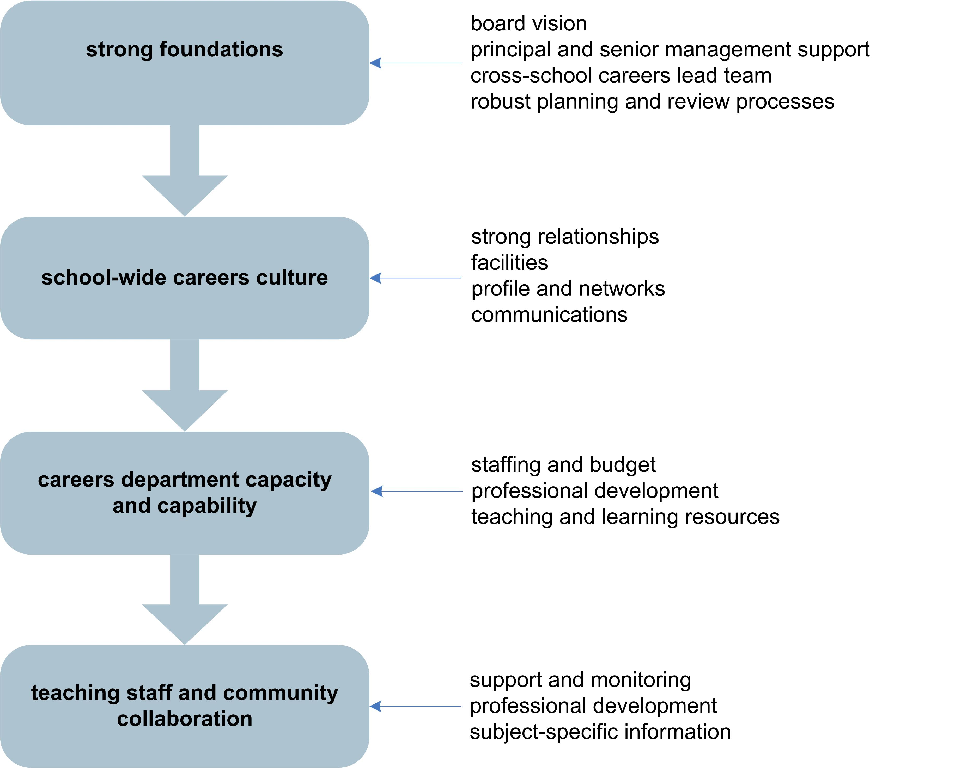

Leadership
Career education is more effective when there is school-wide recognition of its role and value.

Increasing teacher and student understanding of the contribution of career education to student outcomes helps to broaden the concept of career education beyond the work of the careers department.
Gaining school-wide recognition and engagement is more successful when the principal promotes the importance of career education and guidance and demonstrates personal commitment.
The principal can build the presence and profile of career education by:
  - communicating a clear vision of the place of career education and guidance in the school and where it fits into the school’s overall curriculum design
  - working with the board of trustees to include specific goals in the school strategic plan and implementation expectations in annual plans
  - appointing a senior manager to the careers lead team to reinforce the priority and ensure traction
  - actively supporting the careers lead team and addressing any barriers that arise
  - promoting the expectation that all teachers play a role in providing aspects of career education and supporting students as they move through school
  - ensuring that school management systems and documents articulate expectations for career education and guidance.

Careers lead team
Wherever possible careers leadership should be shared by a small team. The size of the leadership role will depend on the diversity of the school culture, the types of career programmes offered, and the level of commitment and involvement of other staff.

Effective teams
Effective careers lead teams:
  - have five or six members who represent a range of roles and views, and include a senior manager as an active member
  - are led by someone with credibility among teachers
  - are stable, well supported and have a clear sense of purpose
  - share tasks and responsibilities and work collaboratively to achieve their goals
  - have or develop expertise in leading change and using information to inform planning
  - have a scheduled slot in the school’s meeting timetable.
Team membership
Team membership, and the ways in which the team operates, will vary.
If career education is delivered through deans and form teachers, a pastoral group will be represented on the team. If the focus is integrating career education into curriculum areas, the team will need to include teachers with subject responsibility, either as departmental heads or with a role to liaise with specific curriculum areas.
Consideration could also be given to including other voices, such as a librarian, a parent, a student, a board of trustees member, guidance counsellor or employer representative.
Team responsibilities
Teams may take a leading role in the following areas:
  - review the career education and guidance provision across the school, in curricular, pastoral and extra-curricular areas
  - identify gaps, based on review and data, and recommend the most appropriate ways to address them
  - plan the development of career education and a strategy to monitor the delivery of career education and its effectiveness
  - consider carefully what support and information teachers need to take on new roles
  - convince teachers to recognise the importance of career education and view their role more broadly
  - enable teachers to appreciate that information about careers can be incorporated into pastoral care and learning areas and can result in better-motivated students
  - maintain the momentum and profile of development activity and refocus attention and energy when other pressures inevitably intervene.
Team accountabilities
What should we be able to demonstrate?
  - Our school is clear about how career education and guidance should be provided and there is clear direction and policy from our board of trustees.
  - We have documented objectives and implementation plans for achieving school goals and expectations.
  - Our career education provision is based on a school-wide approach to delivery that includes career education in pastoral care and regular classroom learning.
  - We have systems and processes in place for tracking student achievement and we evaluate our programmes to show how effective career education is.
  - We are using targeted funds, such as the career information grant and transition and pathway funding, to meet their intended objectives.
  - We have clear evidence that students are making good learning and career decisions as a result of career education and guidance programmes.

School management systems

School management systems and documents can support the development of career education in a variety of ways, for example:
  - school self-review processes include career education
  - departmental curriculum documents provide direction about ways to include career education in each curriculum area
  - departments set career education goals for staff development and student outcomes, and heads of departments report on these
  - staff position descriptions include their role in providing aspects of career education
  - teachers set personal development goals related to career education.
See Career Education and Guidance in New Zealand Schools (2009), pages 26-27, for information on how boards of trustees, principals and senior managers, and career education leaders contribute.

Planning and review
Career education should be “systematically planned at all levels and incorporate a wide variety of pedagogical approaches to meet student needs” (ERO, 2006).

Good strategy is based on good information that tells us:
  - how good current outcomes are
  - what outcomes we should expect
  - what interventions are likely to work.

Tolaga Bay Area School and Gisborne Girls High School are both realising their goal of students gaining qualifications. At Tolaga Bay nearly all students are now staying to year 13, while at Gisborne Girls the number of year 13 students who are going on to tertiary institutions has risen to 80% in recent years. Of those not going on to tertiary education most are in employment, training, or having a gap year overseas.

The planning process
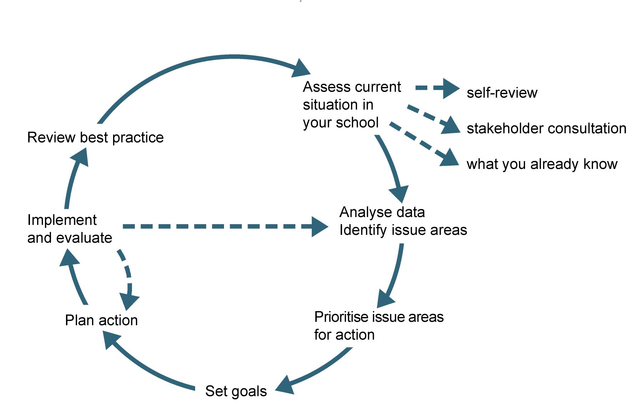

1/ Assessing your current situation

Before reviewing what you do, it is important to review what you know about your students’ needs and interests.
These will set and shape the career education and guidance priorities and programmes you develop for your school.
These needs and interests will not be the same for every student. Within the school community you will have a range of needs, which will require a range of different approaches.
Your school may already collect some useful data, such as the retention of students in senior school, which can provide evidence for a review. But, you may need to gather this data from various places. You may also need to design ways to collect the further information you need.
What do our students need?
  - What are the characteristics of our students: ethnic mix, socio-economic spread, world-view, aspirations, out-of-school activities, etc?
  - What does the data tell us about our students’ motivation, engagement and achievement in school?
  - Where do our students go to post-school? What qualifications do they leave with?
  - What expectations and aspirations do families and whānau have for our students? What are their personal frames of reference for work and study/training?
  - What challenges and opportunities are there in the local environment for our students to gain a broad understanding of the study, training and work options available now and in the future?
  - What broad national and global labour market trends will impact our students’ future education and employment choices?

2/ Setting goals

Having a robust picture of your students’ needs enables you to identify gaps in your current provision and to recommend ways to address these.
Setting goals
What student outcomes do we want to improve? What goals do we need to set for specific groups?
  - The goals you set may or may not be unique to career education. They may involve coordinated effort across the school.
What indicators will we use as evidence of progress towards these goals and how will we measure them?
  - If you set goals that are not easily measurable, choose indicators that will measure the contribution of career education and explain how they relate to the overall goal.
(See pages 14-15 for a list of possible indicators.)
Selecting approaches
What approaches will help us achieve these student outcomes/goals?
  - What does research tell us works?
  - What does our own experience and evidence tell us works in our school? Try to build on and out from your successes.
  - What are we doing now that could be improved or extended?
  - What mix of approaches could we use with which groups of students or year levels, given the resources in our school?
  - How much is required to implement each of these approaches in our school?
When selecting approaches it is useful to look across the school and the curriculum for opportunities to reinforce, enhance and extend learning that takes place in more career-specific activities.
One approach is to do a mapping exercise (or audit) of pastoral and teaching and learning programmes. The mapping exercise should have two goals: to identify where career management competencies are being developed now, overtly or otherwise, in these programmes and to uncover potential opportunities for doing more or better.
Once recognised and acknowledged these opportunities can be documented in team, department or faculty programmes or plans as well as in the career education programme.

3/ Planning action

Use your understanding of what approaches can help you reach your goals and what they entail to set priorities for planned, ongoing growth. Start with the small achievable steps that will make the most difference.
Now you are ready to develop an action plan. An action plan maps out what needs to be done, by whom, when. It will help you to make and monitor progress.
See Career Education and Guidance in New Zealand Schools (2009), page 19-20, for information on strategic planning, setting policy and planning programmes.

Making career education part of classroom learning
There is clear evidence that students who understand the relevance of school to their future lives and careers feel more motivated about school. (Career Education and Guidance in New Zealand Schools, 2009)
Teaching suggestions to develop students’ career management skills:
connected learning  making explicit links between school learning and other parts of life | examples  - skills students are learning, how to do these well, and industries and occupations where they would be useful  - school pathways and tertiary options related to the subject; opportunities and requirements of subject-related industries
contextualised learning  designing activities that reflect or involve the world of work | examples  - real-life contexts for projects, simulations and role play  - learning activities that allow learners to develop and share their individual career aspirations and interests  - guest speakers or professional assistance in the classroom  - field trips, collaborations, challenges, school or community projects  - work exploration and work experience
career foundations  helping students develop key competencies | examples  - feedback, affirming successes, interests, skills, talents and abilities, portfolios  - recognising own strengths and interests  - information-seeking behaviours, study skills, and task planning skills  - organising self, setting goals, reflecting on completed tasks
career management  helping students apply competencies to career decisions, and developing their career specific skills | examples  - assessing relevance of talents and current skills to career options  - exploring work values, career beliefs, ways of maximising flexibility  - CV writing, interviewing and job search skills
career guidance  guiding students to resolve questions and develop strategies for success | examples  - expert wrap-around support  - discussion of attitudes to work and future, challenges and strategies

Planning for specific groups

These questions and examples may help you plan strategies to meet the unique needs of specific groups of students in your school. Not all students in a specific group will need the same level of information and support.
Within general programme
What can you build into all your current activities that would make them more successful with a specific group?
  - project work looking at roles that are important to own culture or community
  - investigating different communities’ ideas about work
  - exploring the role of family or whānau in career decisions.
Targeted activities and support services
What can you add to your current activities that would value and make a significant difference to all students in a specific group?
  - face-to-face introduction to the careers team on entry to school
  - visits to or from local iwi businesses or community business associations
  - family, whānau or community activities or career events.
What specific guidance would help particular individuals in a specific group set realistic goals and make informed decisions?
  - additional support with subject selection, learning and career planning
  - aspirational events or workshops for Māori or Pasifika students
  - information and guidance for family or whānau groups.
What specific support would help identified individuals in a specific group re-engage?
  - goal setting activities with students and whānau
  - mentoring (peer and/or external)
  - introduction and referral to relevant external support agencies
  - work experience.
School-wide and community programmes
Where a specific group is large, the school may plan a school-wide programme that carries into every classroom and enhances the school’s interactions with the community.
  - school-community-based programmes like whānau programmes, community liaisons, learning mentors, motivators or coordinators, etc.
  - Ministry of Education programmes, such as Te Kotahitanga, Home-school partnerships.
What career education and guidance approaches could build on and contribute to this programme(s)?
Specifically designed curriculum options
What can you build into your current options that would make them more successful with a specific group?
  - more flexible curriculum, eg. two semester system or integrated learning across core subjects in years 9 and 10
  - vocational courses (eg. through STAR, Gateway, ITOs)
  - alternative courses in core subjects
  - language courses.
What kind of curriculum options would help particular individuals gain qualifications and start to build a career?
  - integrated work-related learning in senior courses, eg. drivers licence, first aid certificate, health and safety.
What kind of curriculum options would keep these students at school and help them start to build a career?
  - alternative programmes centred around students’ interests and needs that provide work-related experiences in the community.

Design and evaluation

Programme structure
A career education programme, or scheme, sets out the range of actual learning opportunities, interventions and interactions that the school provides.
A career education programme needs to:
  - meet the needs of all students across all levels from year 7 to 13
  - link with career-related events in students’ lives
  - actively involve the community.
An effective programme will:
  - make it clear which career management competencies and learning outcomes are priorities
  - maximise connections and coherence with other school strategies, programmes and learning
  - provide for individuals and groups of students with specific needs.
Programme components
The possibilities include:
  - career education delivered in pastoral care and curriculum areas
  - stand-alone career programmes with a dedicated period or line on the timetable
  - career information activities in and outside the school, such as careers nights, speakers
  - real experiences of work and tertiary study, including through pathways and transitions funding (eg. STAR and Gateway)
  - transition education courses and alternative curriculum options
  - individualised support (through pastoral care, careers staff, guidance counsellors and/or external specialists, mentors)
  - specialised group programmes, for example, for new arrivals to New Zealand, Māori, Pasifika, gifted and talented, or students with specific support needs.

Design process

The same principles apply to designing or reviewing career education programmes as apply to other teaching and learning programmes, especially those which have strong elements of cross-curricular and community engagement.
For each component in the programme:
  - define the focus or aim. How does this component contribute to programme goals? What are the links to the other parts of the programme?
  - define the learning outcomes. What do we want the students to learn?
  - develop the teaching and learning approach. What approach will best achieve the learning outcomes? Where, who and how will this be delivered?
  - develop the content outline and locate resources
  - consider ways to inquire into the success of the teaching approach. How can we check learning is taking place?
For the whole programme consider:
  - ways to assess and give feedback to students as they progress through the programme
  - what information you will gather about individual students as part of the programme, for example, in student profiles, how you will use this information and how you will make it available to others in the school, including in what format.

See Career Education and Guidance in New Zealand Schools (2009), pages 46-51, for suggested learning outcomes

Planning evaluation

Evaluation is an important contributor to curriculum design and review. It needs to be planned and selective.
Evaluation involves:
  - identifying what the evaluation will focus on and why
  - selecting appropriate indicators of the student outcomes you are seeking to achieve
  - using efficient, fit-for-purpose ways to measure these indicators
  - gathering and interpreting relevant evidence
  - identifying actions that need to be taken on the basis of that evidence
  - reporting and discussing findings.

Ideally, you should develop an evaluation approach for the programme at the time you are designing it.
Decide which major components of your programme need to be evaluated regularly and which might need to be looked at from time to time.
Make sure you are clear how each piece of evaluation you do will contribute to the overall understanding of the effectiveness of career education and guidance.
Most importantly, plan how you will use the evidence you get to inform future planning and review.
Evidence needs to be interpreted and interrogated. Discuss it with key people and take their explanations and insights into account when drawing up conclusions.

Collecting evidence

Consistently collecting evidence will help build up a picture of student outcomes that could be partly attributable to career education and guidance.
It is helpful to maintain quantitative and qualitative data in a way that enables you to track and report on outcomes and trends for specific groups and component programmes.
Your school management system is a key source of data, such as ethnicity, special needs, attendance and behaviour, academic progress and student destinations. Find out how your school is analysing this data and whether this analysis can assist you.
For other indicators you will need to design ways to collect and collate the evidence. You will probably use a mix of methods, ranging from structured instruments and processes like student assessment results, evaluation forms, surveys, discusion groups, interviews and synthesis of written records, to less structured activities like observation and discussion.
Two important sources of evidence are students and teachers. You will need to design ways to:
  - monitor and get feedback on components of the programme that involve others, eg., teachers, parents, external providers
  - explore students’ views of career education and what they need
Remember that people like to know what their comments have led to. Show them their views count by telling them what changes are being looked at or planned.

See Career Education and Guidance in New Zealand Schools (2009), page 20-22, for information on evaluation and review, and destinations tracking.

Possible indicators

Leadership
  - the school’s strategic plan has goals and outcomes for career education and guidance
  - the principal participates in, or leads, professional development for staff around career education and guidance
  - the careers lead team has broad school representation and includes a senior manager
  - the senior management team regularly liaise with the careers lead team
  - the senior management team has approved the plan for career education and allocated sufficient time and resource
  - careers staff have formal position descriptions
  - department plans have goals for career education
  - staff position descriptions articulate their role in providing aspects of career education and guidance
Student outcomes
  - career education teaching and learning materials state the relevant learning outcomes from Career Education and Guidance in New Zealand Schools, Ministry of Education, 2009
  - up-to-date student profiles and/or learning and career plans
  - number of individual interviews with students
  - number of students changing subjects at the beginning of years 11, 12, 13
  - number of students gaining career-related standards
  - qualifications attempted and gained
  - retention statistics at years 11, 12, 13 and early leaving statistics
  - leaver destination statistics

School-wide engagement
  - teacher involvement in student guidance for subject choice
  - processes for using students’ possible intended pathways in curriculum design
  - number of courses available at senior level
  - teachers’ planning documents have careers content or links
  - departments’ reports to the board show that career education is included in their teaching programme
  - departments’ minutes make reference to discussions about career education
  - noticeboards in staffroom, classrooms, corridors, etc have careers information
  - career resources are visible in classrooms
  - staff handbook, which supports the students options booklet, provides basic information on entry levels to occupations
Teacher knowledge
  - professional development register and evaluations
  - the school’s teacher induction programme has a careers component
  - requests from staff for careers-related professional development
  - enquiries from teachers for information from the careers department
  - number of students referred by teachers to the careers department and reasons for these referrals

Possible indicators

Programme design
  - documented career education programme or scheme of work
  - documented process for evaluation and review of career education and guidance
  - reports to the board on the effectiveness of programmes
  - student self- and/or peer assessments of learning in career education
  - student and staff views on career education, Gateway and STAR
  - evaluations of targeted careers events for Māori, Pasifika and students from other cultural backgrounds
  - register of students at risk of being unprepared for transition to work or further education and training, and those with diverse needs, and records of specific interventions for these students
  - numbers of students at careers evenings, events or sessions
  - electronic resources used in programmes
  - computer room booking sheet shows use for career education
  - career education information and tools for students on the school intranet
  - figures on students’ independent use of computer career tools
  - students on Gateway and STAR programmes
Family and community engagement
  - career education items in school newsletters, website, local papers, etc
  - log of contacts with families that includes career education (all staff)
  - feedback from, and feed forward to, families on career appointments
  - invitations to families and community to participate in career-related activities
  - numbers of families attending career appointments with students
  - numbers of families attending career expos with students
  - numbers of families attending school information events, eg subject choice, report, and numbers of those who see the careers adviser at these events
  - careers staff attendances at whānau or aiga meetings
  - register of local business contacts for work shadowing, work placement and training
  - log of work experience, STAR and Gateway activity
  - numbers of students doing work shadowing, work placements and training with local industry
  - number of career-related speakers in the school (parents, ex-students, etc)

“Two amazing women came in from the Pacific Island Resource Centre. We saw kids raising their aspirations as a result of the course, with some saying ‘I want to be a leader in my community. I want to be someone that people will look up to’.”

Management and delivery

Personnel
A school-wide career education and guidance programme that provides learning opportunities to students across all years of the school needs the support and involvement of skilled, knowledgeable teachers and of a range of people and organisations from outside the school.
Questions to ask each year include:
  - Are we continually building our careers delivery across the school? Who else is enthusiastic and willing to be involved?
  - Have we enough teachers to help deliver in the coming year? Do we need to develop staff for following years?
  - Can we increase family and community involvement in aspects of our programme? Who has industry experience we can utilise?
  - Where will we use external specialists (eg. intensive work with individual students, career workshops for parents, career education planning)?
Professional support
To ensure a school-wide programme is consistent and coherent careers staff need to monitor and support teachers and other contributors.
  - What monitoring will we need to do to ensure quality across all programmes?
  - How much and what kind of support will people need from careers staff (eg. preparing lesson plans and teaching resources, advising on where to find current information) and how can we efficiently deliver it (eg. staff meetings, one-to-one)?
  - How much professional development will careers and other staff need? How will this be funded? Who will deliver it? What is available? (In-house, external specialists, industry events, conferences, etc.)

Timetable

One of the most commonly mentioned issues in implementing career education is timetabling, especially when a programme is to be integrated across a number of departments. Suggestions made to alleviate these problems include:
  - coordinating delivery of the programme to coincide with subject selection
  - using form times
  - organising school-wide careers weeks
  - block delivery
  - short programmes for students who are not doing the subject in which the core programme is offered
  - informing staff early in the year of dates of career events, such as subject choice evenings and career expos
  - ‘borrowing’ classes from other subjects or the relief system.
“Schools tend to include the components of Developing self-awareness, Making decisions, and Taking action as specific modules in a curriculum subject or in tutor time. Schools increasingly expect teachers to support the component Becoming aware of opportunities by including references to jobs that relate to their teaching subjects.”
(ERO, 2009)

Financial management

Income
The primary source of funding for all teaching and learning activities in the school, including career and transition education, is the Operations Grant. Three important additional sources of funding for schools for career and transition education are:
  - Careers information grant. This is based on the number of students and the decile rating of your school
  - STAR funding. Refer to A Guide to the Secondary Tertiary Alignment Resource (Ministry of Education, 2006)
  - Gateway funding. From 2006, all schools are eligible to apply for this funding. Refer to the Tertiary Education Commission website (www.tec.govt.nz) for details.
Funding rates change. For details you can contact your local Careers New Zealand office, your local School Support Services adviser, or go to the CATE website (www.cate.co.nz).
Expenditure
Allow for as many contingencies as possible. Here is a list of the types of items you may need to budget for – from career education or other budgets, depending on your school.
  - career education resources, especially those with student workbooks. Allow for extra sets
  - publications, course directories
  - internet charges, photocopying, paper for computer room, printer cartridges, laminating costs
  - course costs (on or off site), including external providers
  - professional development, teacher release, conferences (for self and others)
  - external specialist support for classes, groups, one-to-one guidance, board of trustees presentations, etc
  - trips (buses, vans)
  - professional association subscriptions (CATE, CDANZ)
  - capital items, such as filing cabinets, CD/DVD players
  - storage materials and display stands
  - own mileage for meetings, including with employers, and transport of students
  - secretarial or administration support
  - materials and food for parent evenings…

Example spreadsheet for income:
Careers information grant | number of students in years 9-13 | rate for decile | total = students x rate
STAR funding (use calculation table in the guide to STAR, p30) |  |  | Enter here
Gateway funding (if applicable) |  |  | Enter here
Other |  |  | Enter here
Total available funding to your school |  |  | = sum of above

Documentation
Up-to-date documentation is important for supporting and sustaining provision. Your school will have a standard approach to management documentation that you will need to apply. This diagram sets out the types of documentation that might be useful for sustaining and developing career education and guidance.

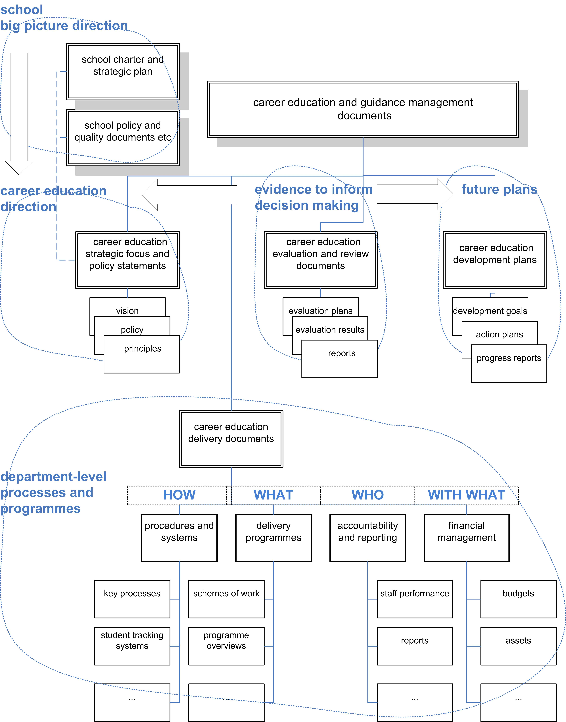

Communications and profile

The profile of career education in your school is a good indicator of the level of school-wide recognition of its importance.
Some suggested ways to raise the profile of careers include:
  - consistently present career information in assemblies and form times
  - maintain a presence at report evenings and arrange the presence of outside agencies, such as StudyLink, at such events
  - ensure visual information (such as posters) around the school is current
  - give presentations at staff meetings and board of trustees meetings to introduce new initiatives and highlight current successes
  - encourage other teachers to attend career-related professional learning opportunities
  - use past students as role models of success
  - place good news stories in school lobby, website, newsletters, magazines and intranet
  - ask local newspapers to do stories on successful work experience or work shadowing (draft these yourself if necessary, and provide photos if possible)
  - let parents/caregivers know about things they can do with their children, such as web-based career information and tools they can use together from home, the nearest career expos and other local career events
  - provide career information for school prospectus, subject options booklet, staff handbooks and departmental documentation.

Careers presence on the school website

Many schools have career information and tools on their intranet that students and parents can access. Some have careers information on their websites.
A good careers site has a link on the school’s home page and gives:
  - the name and contact details for the careers adviser
  - a location map and photos of the careers centre or room
  - an outline of what career education and guidance is about at the school
  - an up-to-date year planner showing what’s happening
  - subject choice information, including what to consider when choosing school subjects
  - information on planning a career
  - information for parents on supporting their child
  - scholarship information
  - links to useful websites, especially to the Careers New Zealand’ site, but also to tertiary providers, ITO sites, job hunting sites etc
(ERO, 2009)

Career education resources

Effective career education and guidance programmes provide students with access to a wide range of quality, up-to-date resources, and help them develop the skills they need to use and understand these resources.
It is important to review the career resources you use to deliver your programmes every few years to decide what you need to revise, develop or purchase.
  - Are these resources current and appropriate for the target year level(s)?
  - What do students think of them?
  - Are they easily understood by other staff?
  - Do they promote equally positive images of academic and vocational occupations and pathways?
  - Do they meet the needs of specific student groups?
  - What alternatives are available now?
Increasingly, career resources are electronic and internet-based. To provide students with access to online resources involves:
  - booking computer suites ahead of time for class use
  - making sure that students and staff can access the relevant sites or programmes, and that they have the skills to use them
  - providing computer access in areas such as the careers room and the library so that students can use these resources independently as they require
  - displaying recommended websites prominently next to computers provided for students to use.

Student information

Recording student information can be done in a variety of ways. Before developing a careers department records system think about:
  - What information do you need and for what purposes?
  - Who else needs or should have access to the information? Students, wider school staff, parents?
  - Where will the information be stored?
- well-designed databases allow easier sharing as well as easier analysis and reporting of career-related data, as long as there are clear rules controlling the way content is entered
  - Who enters and/or edits the information?
- for example, student management systems (SMS) can be set up so all staff can access information but only selected staff can enter or change information

  - How will access to confidential information be managed?
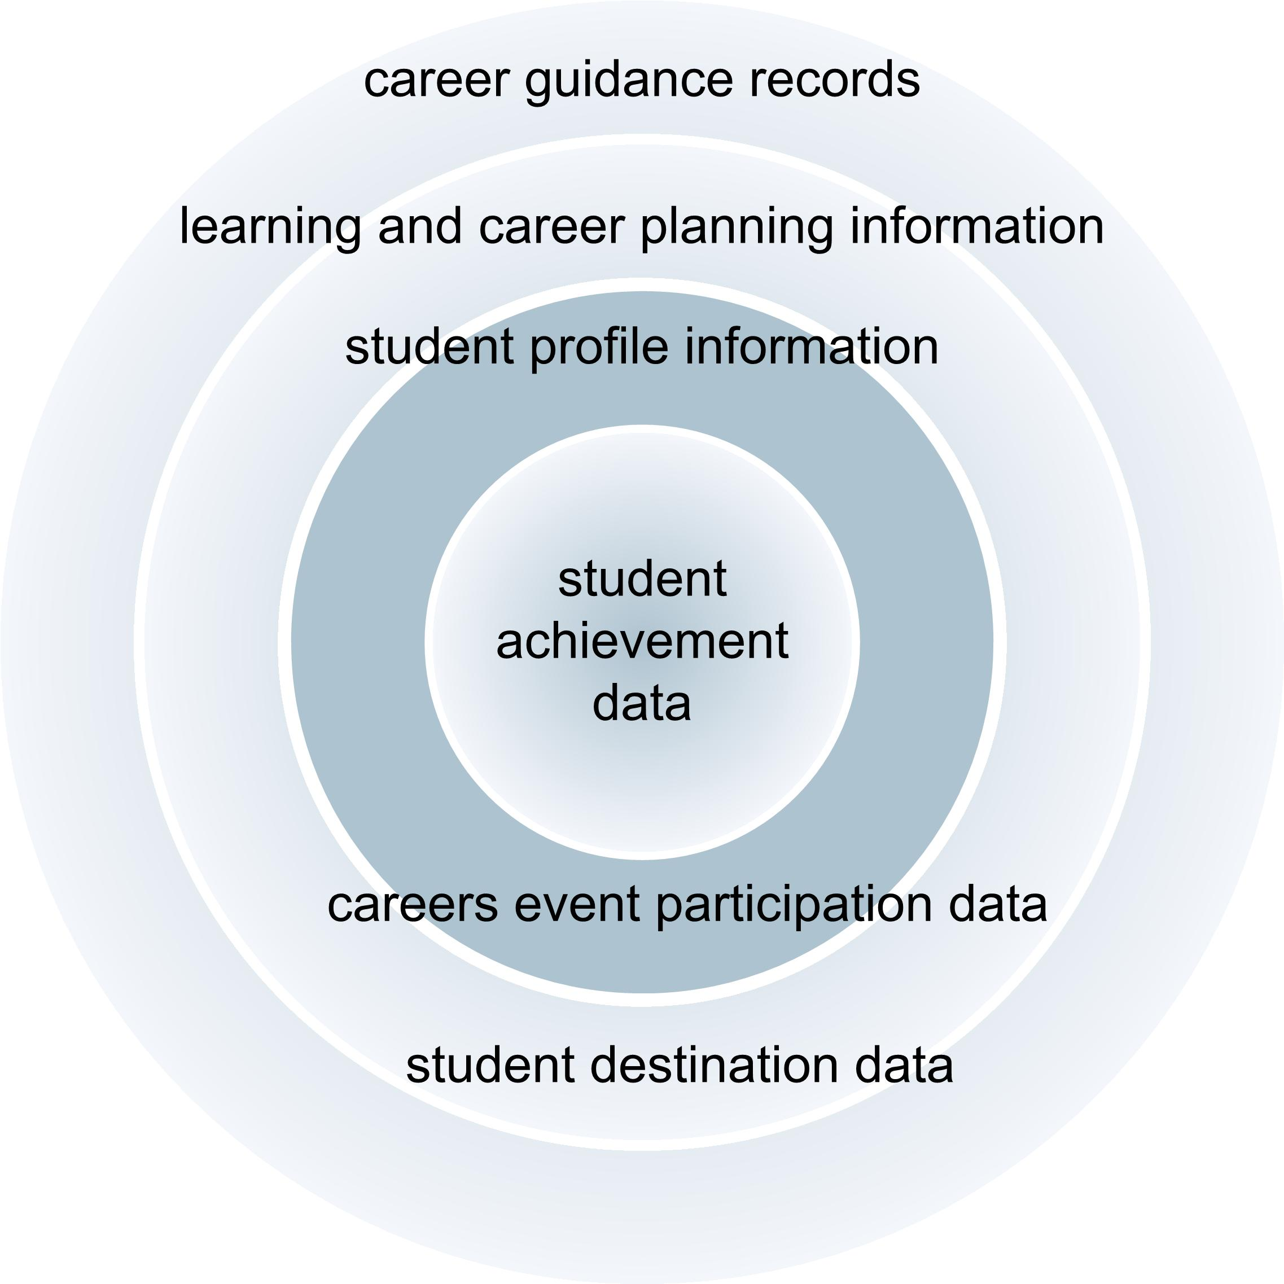

Career information management

Maintaining high-quality, up-to-date, organised and accessible collections of career information is a major task for a careers team. Where possible this information should be electronic and accessible through the school computer network so students and staff can access these collections or databases, as appropriate, where and when they need.
Essential items include a calendar of career activities and database(s) or collections of career information.
Career calendar
This could include dates/due dates for:
  - all known career events, such as expos, industry training organisation events, tertiary liaison visits, Workchoice days, report evenings, career evenings and seminars for parents.
  - professional development workshops, meetings, etc
  - reporting on career education to management and the board of trustees
  - compiling key communications, such as newsletters, that go to staff, students or parents
  - submitting applications to tertiary institutions.
The Careers New Zealand website has a list of monthly events in regions around the country.

Career information databases and collections

There is a wealth of career information that students and teachers need quick and easy access to. A lot of this is already available online in a useful format, some in paper versions as well. In other cases, you may need to create your own database to bring information together in an easily used form.
A virtual catalogue of online information can be created by adding relevant website links into named folders in your ’Favourites‘ (or equivalent).
Types of career information that careers staff need to keep current collections of include:
  - tertiary calendars, etc. Schools receive significant amounts of information from an increasing number of providers. Some providers offer hard copy information as well as online information
  - a register of Private Training Establishments, local and national (NZQA)
  - information on Training Opportunities and Youth Training courses (TEC)
  - details of student loans, allowances, scholarships (StudyLink)
  - information on local government and community agencies and the career-related services they provide for young people
  - a database of local businesses and organisations willing to provide work experience
  - a list of Pasifika and Māori student liaison officers in tertiary institutions.
  - STAR course information

Relationships

Engaging school managers
To gain and grow support for career education and guidance in your school, the careers leadership team need to provide the principal, senior managers and the board of trustees with relevant information about the objectives and outcomes of the career education programmes. This could include:
  - the benefits of career education to your students and your school
  - how career education in your school is meeting the needs of students (overall and for specific groups of students) and the requirements of NAG 1.vi
  - evaluation material (from surveys, etc) showing outcomes and trends related to career education
  - overview of current programmes, including integration into regular classroom learning

  - progress on developing new programmes
  - emerging issues and challenges, future goals and budget implications
  - student and family participation in career information and education activities
  - professional development and staff who have attended
  - good news stories.
It is also useful to report the time careers staff commit to career education and guidance, including the time spent outside school hours.
See Career Education and Guidance in New Zealand Schools (2009), pages 26-30, for information on the roles and contribution of school and community members to career education and guidance.

Engaging teachers
“It boils down to sharing the load and getting teachers to make some time in their programmes where students can explore jobs or pathways related to the subject, so everyone takes responsibility.”

You can’t do it all on your own. To extend delivery of career education means building a school-wide understanding of career education. This includes:
  - promoting the goals and outcomes of career education in your school
  - promoting the benefits to teachers of involvement in career education, such as developing their relationships with students and increasing their own knowledge
  - identifying and sharing practice that improves student achievement
  - highlighting the links between career education and the key competencies
  - helping teachers to include career education in their planning and classroom delivery.
Strategies to encourage involvement include:
  - involving enthusiastic teachers and using their example to generate interest and support from others
  - identifying teachers to take on a liaison role for their syndicate, department or faculty
  - preparing lesson plans and resources for teachers
  - modelling or co-teaching some career education activities
  - providing opportunities for teachers to update their knowledge of the links between their subjects and the job market
  - organising inter-school career education development meetings/exchanges for subject areas

Engaging students

Students benefit from career education that broadens their understanding of the world of work and helps them build connections between people’s learning, abilities and interests, and the careers they pursue.
Student engagement increases with:
  - positive relationships with knowledgeable and highly skilled teachers
  - recognising their own strengths and interests and how they link with their learning and their futures
  - developing their understanding of ‘career’ and having opportunities to explore future options that suit their strengths and interests
  - enjoyable learning experiences that include exposure to real people and real situations
  - out-of-school experiences, such as inspirational or aspirational events, work experience or tertiary tasters
  - opportunities to hear from other young people about their experiences.
Engaging Māori and Pasifika students
Māori and Pasifika students will be engaged when they see connections between their cultural experience and workplace success.
Research by Aatea Consultants (2005) finds that Māori students:
  - see positive relationships as very important to their engagement in career education and guidance
  - desire personal involvement and discussion not only about themselves but also about their family
  - want to hear about the experiences and successes of others, especially Māori role models, rather than see a book or CD.
In Pasifika families, decisions about students’ learning and career are often a family matter. Pasifika students want help explaining their aspirations to their parents (Ministry of Pacific Island Affairs, 2003).
Many schools involve Māori or Pasifika staff, external career specialists, or local community members in career education for Māori and Pasifika students, where possible.

Strategies schools use to support Māori and Pasifika students include:

  - interviewing all Māori and Pasifika students at the beginning of the year to establish a positive relationship
  - integrating career education into a te reo bilingual unit or programme
  - employing careers assistant(s) to build relationships and work with students in small group sessions (for example to develop CV’s and gain unit standards)
  - using Māori or Pasifika speakers who can illustrate ways that their ethnicity, culture and/or language is an asset to their careers
  - using community success stories in teaching and learning activities
  - using year 13 students, past students or members of community groups as mentors
  - arranging for students to attend Māori or Pasifika career expos and workshops
  - selecting students to attend Māori or Pasifika career aspiration programmes or achievement programmes designed to inspire and motivate senior students to further education (often students with untapped potential who are unlikely to perceive themselves as achievers).
To encourage tertiary participation:
  - putting students in contact with Māori or Pasifika tertiary liaison officers
  - taking students to information days at tertiary providers
  - selecting students for work exposure programmes run by some tertiary providers to encourage the participation of Māori or Pasifika students in various tertiary courses (eg. health)

Engaging students at risk of not making successful transitions

Students who are at risk of leaving school unprepared for the transition to the workplace or further education/training are students who leave school without developing the career management competencies they will need to manage their futures.
They include students who leave school without considered career plans or unprepared for their intended pathways. They can include students who have been successful at school as well as those who have underachieved. In New Zealand schools, Māori students, refugees, Pasifika students and migrants have been identified as more likely to be at risk.
These students are more likely to be identified when school systems such as guidance, pastoral care, health care and attendance are coordinated and communicate promptly with each other.
Appropriate guidance and follow-up, including relevant careers information, will restrict the numbers of students ‘falling through the gaps’ in school. Schools report that early intervention is the most effective and some are now looking at implementing programmes traditionally held for senior students at a junior level.
The ideal approach for working with these students is individualised, holistic support from people who care about them. This approach is likely to involve emotional support and practical help, as well as developing learning and career planning skills. It is likely to need to be slow-paced and longer-term (NZCER, 2004). It is supported by documenting the actions to be taken and monitoring to ensure action is taken. (ERO, 2006)
Students who received individualised support and guidance through the Designing Careers project said they:
  - felt more valued
  - enjoyed the events they participated in
  - valued the opportunity to talk to people outside the school and get independent advice on work or training options.

Different interventions that schools use to engage these students include:

  - one-to-one support from a careers adviser or external consultant on referral from the guidance counsellor, dean or year level coordinator
  - transition classes or alternative courses in mathematics or English often using career materials as source materials
  - employability skills training, work shadowing and work experience in Gateway programmes, or alternative programmes such as ASDAN Youth Award schemes, gaining credits towards NCEA
  - courses purchased from tertiary training providers offered in school time, on site (eg. NZ Agriculture ITO courses), or off site (eg. forestry and carpentry classes at a local polytechnic or private tertiary provider)
  - involvement of community services such as Youth Transition Services
  - employing external consultants in social and employability skills to work with identified year 9 and year 10 students – and their families, where appropriate
  - visits to possible workplaces.

Engaging families

Parents and whānau are a key influence on students’ development of aspirations, educational achievement and future decision-making. They give their children general advice about how to do well in life, as well as ideas from their own learning and career experiences.
Engaging family in career education helps to:
  - enhance parents’ understanding of schools and students’ learning processes
  - update parents’ understanding of careers, the job market and qualifications
  - provide ways for parents to be included in their children’s learning process (evidence shows that most parents want to be)
  - enhance the school’s standing in the community and build trust.
Ways that schools build home-school collaboration for career education include:
  - careers presence at enrolment, subject selection evenings, report evenings and year level parent forums
  - goal-setting meetings between students and their parents and the form teacher
  - career centre open days, parent career evenings or workshops, careers hui at local marae
  - attending whānau committee meetings, or visiting local churches that students and their families belong to
  - incorporating components into careers units for parents to discuss/review
  - including careers information in material that the school sends home, such as newsletters and orientation packs (providing key information in parents’ own languages, if possible)
  - including requests in material that the school sends home for parents to participate in career talks or facilitate a visit to a workplace
  - offering childcare and transport for parent evenings.

Engaging the community

Effective career education involves the support of the wider community, including families (Dusseldorp Skills Forum, 1996).
Schools and their communities work together in a variety of ways to enhance career education opportunities for students. Employers, service clubs, community and iwi organisations, extended family and friends are key sources of work experience, scholarships, tutoring (literacy), role models and mentoring for students.
This engagement helps to:
  - create a wider school community prepared to work together to benefit students
  - foster a sense of value and belonging to the community for students
  - foster an environment of shared knowledge where complementary skills and understanding are developed
  - increase resources for and skills of students through extra-curricula experiences and education outside the classroom
  - provide a network for students to more easily find future employment and training.
The key to maintaining community support is acknowledging what they do for students and celebrating the difference it makes. Ways of doing this include:
  - inviting them to informal get togethers, where students tell their stories
  - inviting them to prize-givings and other big school (careers) events
  - organising features in local media about their role in student success.
Businesses
The relationship between schools and employers is frequently one of mutual support: schools ask businesses to help them provide work exploration opportunities for students; and businesses ask schools to help them find potential employees from among their students. Businesses may also help schools by identifying employees who would enjoy talking to students about their occupation, perhaps in a subject class, or acting as a mentor/guide for a group project.
Schools in some areas work hard to find enough businesses to provide work experience and work shadowing for their students. Those in smaller urban or rural areas sometimes find it easier due to the closeness and support typical of such communities, even though there is not the number of businesses available in large urban centres.
Approaches that schools use to find work experience opportunities for students include:
  - approaching ex-pupils or the families of current pupils
  - using the personal and professional networks of individual staff members
  - advertising in local media for positions for work experience for students
  - including a component in the senior programme (for example, in a unit on the world of work and training) where students look for their own work experience opportunities, by preparing a CV and a formal letter of introduction and then approaching their own contacts
  - approaching businesses in industries that students are most interested in and providing them with evidence of students’ interest and their potential as future employees
  - through events such as Workchoice days.
Tertiary education and training providers
Tertiary education providers frequently initiate contacts with schools. Some are available to visit schools to meet with students and advise on course provision and subject choice within courses. Some offer career aspiration programmes or work exposure camps to inspire and motivate senior students to further their studies in general or specific tertiary programmes.
Industry training organisations also initiate contact with schools. They may have representatives in your area that can link young people to training in a range of industries. It is useful for you to get to know who these people are. The Modern Apprenticeship website (www.modernapprenticeship.co.nz) and the Industry Training Federation website (www.itf.org.nz) both carry information about the types of apprenticeships and training available, typical questions asked by young people and contact details for local representatives.

Case studies
Tamaki College: Engaging parents

What are you doing now?
The school holds monthly meetings for Tongan students and their parents to discuss and develop solutions to issues facing the students and their families. The meetings are run by Tongan staff and external facilitators as required.
Why did you decide to do this?
When the school reviewed student behaviour, literacy and NCEA statistics, they found that Tongan students were not performing as well as other students. The school recognised that parent involvement was essential to turning the situation around.
What is the result?
An encouraging number of parents attend the meetings (47 parents of 160 Tongan students). Parents feel they are better equipped to support their children. They are more informed about NCEA, literacy and numeracy requirements and career pathways. They feel empowered with improved parenting skills. Students also say they want the school to continue helping their parents.
What did you have to do?
The initiative was aided by the fact that the principal is Tongan. The school began by having a series of discussions, first with Tongan church leaders and then parents, where issues about student performance were communicated in a ‘no blame’ way. In a subsequent meeting, parents were encouraged to openly and frankly discuss the issues facing their children. The parents said they would like to learn parenting and anger management skills, and also receive information on careers and NCEA.
The programme requires time and effort from Tongan staff and members of the Tongan community. Having Tongan presenters, or palagi presenters with interpreters, has contributed to the success of the programme and members of the community voluntarily give their time to help with this.
Do you have any plans for next steps?
The school plans to offer similar programmes to other ethnic groups in the school. They have already begun the process with Māori parents and will focus next on the needs of Samoan students and their families.

Case studies
Linwood College: Exploring opportunities in year 11 science

What are you doing now?
Science teachers and careers staff teach a short unit of work in the careers room. Students learn how to access information on career opportunities in the different fields of science and research a specific job in the field. Posters of young people in science careers highlight the possibilities that exist.
Why did you decide to do this?
The initiative arose out of the school’s concern that students lacked an awareness of possible future pathways and careers in science. It was also partly a response to general concern in New Zealand over the low numbers of pupils taking science at school and tertiary level.
What is the result?
Teachers believe that these students are making more informed subject choices and have a heightened awareness of how science links to other subjects and how it can be used in practical ways. Some teachers have also reported that students appear more motivated to learn in this subject.
Students also realise there are career advisers to help them and resources available to use. The science teachers have developed knowledge of post-school study and training options and an understanding of career education.
Do you have any plans for next steps?
Science teachers have asked to continue this approach with year 11 students. Teachers in other subject areas are increasingly requesting something similar but the school has not yet had time to develop career education integration plans with other curriculum areas.

Golden Bay High School: Exploring opportunities in year 10 technology

What are you doing now?
A 13-week unit of work in the ICT programme incorporates many aspects of careers exploration. The unit is rotated through all three year 10 classes.
Students start by familiarising themselves with the Careers New Zealand website and looking at a given occupation. They are encouraged to consider a range of investigative questions they might ask when thinking about a career choice (eg. full- or part-time, pay, using their qualifications, location). Then they research a range of careers and tertiary institutions and work out the costs associated with study. They are required to prepare a final presentation (usually in PowerPoint or Publisher) describing aspects of their career path, using a flow chart to describe whether training or further study will be an option, and the social impacts of choosing a particular career.
Why did you decide to do this?
The school was looking at ways of updating their existing careers education and the ICT teacher was interested in getting students to think about their future pathways and help students make informed choices in subject selection for year 11 and beyond. She also wanted students to know how her subject would be beneficial to and fit in with their desired career options and make deliberate choices about their study in senior school.
What is the result?
The students engage well with this unit of work. They seem to be making more informed choices about the subjects they will take in senior school, choosing subjects to fit their career plan rather than picking subjects based on what their friends might be doing etc.

Part 2 : Learning and career planning
This section presents information on learning and career planning at year 10. It draws on the findings of the evaluation conducted by the Education Review Office on Designing Careers, a two-year project (2005-2006) in 75 secondary schools to increase capability and capacity in delivering career education.

Purpose and approach
“Gets you thinking. You realise what you’re good at. It opens your mind to reality. How close and the cost. Researching careers shows it’s more than a dream.”

The goal of learning and career planning at year 10 is to lay the foundations for lifelong learning and career development. It aims to develop students’ self-knowledge, aspirations, learning goals, and understanding of career planning in general terms.
The planning process encourages students to think about a range of career options and gain an understanding of the different pathways open to them. It helps them to learn where to find information and develop the skills and knowledge to make informed subject choices.
Implementing learning and career planning at year 10 requires a wider career focus across the school. It requires the involvement of teachers in different curriculum areas, pastoral care and/or form time. These teachers need professional development and support to give them the knowledge base and confidence they need to take on this role.

Outcomes
“Students are actively thinking about career pathways. They are more motivated and they are making connections between their school study and their longer term career goals.”

Schools that implemented learning and career planning at year 10 in 2005-2006 through the Designing Careers project endorsed the development of a learning and career plan as appropriate and useful for year 10 students.
Outcomes they reported for students included:
  - increased knowledge about careers and about themselves
  - increased understanding about the relevance of school to future goals
  - improved subject selection
  - increased motivation and engagement
  - raised aspirations
  - improved relationships with teachers.

Students were generally positive about developing a learning and career plan and discussing it with their parents. They reported the best aspects as:
  - finding out what jobs or subjects might suit them
  - learning about a variety of jobs
  - getting ideas for the future
  - developing a sense of direction, and
  - getting guidance on choosing their subjects.

The planning process

Students’ needs
Students at year 10 need to know about:
  - career options that relate to their interests
  - the best subjects to take
  - where to get and who to ask for information about jobs and careers.
They are less interested in knowing about a particular career or job and believe there is still plenty of time to make these decisions because of their age.
They want schools to help them by giving them:
  - information on qualifications needed for a range of jobs
  - opportunities to learn about work
  - assistance with subject choice
  - advice and encouragement to investigate career options open to them.
Meeting students’ needs
Learning and career planning activities should use a range of resources and approaches that provide opportunities for students to explore:
  - their strengths, interests and values
  - a range of careers that might suit them
  - the subjects they would require for some of the career options that interest them
  - how to avoid closing off future options.
They should offer students opportunities to talk to a teacher about their options post-school. For some year 10 students this may be the first time they have really done this.
There are benefits in linking learning and career planning to subject selection but schools can timetable this planning at any time that suits their students, and this could be spread out over the year.

School-wide focus
The staff felt encouraged and inspired from the PD… they felt they had tools to use and confidence to use them. [They] felt more confident in taking action themselves when working with students, rather than immediately referring them to Careers.”

Implementing learning and career planning at year 10 requires a wider career focus across the school. It requires the involvement of teachers in different curriculum areas, pastoral care and/or form time.
Teachers need to develop their knowledge base and confidence to take on this role. This can be done through appropriate professional development sessions or activities, in some cases involving the whole school.
Practical support from careers advisers is also important. This may include:
  - helping to deliver units of work in other curriculum areas
  - providing teachers with lesson plans and high quality, accessible and easily transportable resources
  - preparing multiple copies of the resources so that several teachers can deliver the material simultaneously.

Delivery
The evaluation of the Designing Careers project did not find any one delivery approach, whether integrated or not, more effective than others.

Learning and career planning can be implemented in a variety of contexts. This often includes Social Sciences, Health, English, pastoral care and/or form time.
Some advantages and disadvantages of delivery in a variety of areas are
In pastoral time
  - done in sections throughout the year
  - provides an opportunity for form teachers to get to know their students better
  - form teachers may need time off from other subjects so they can work with their students
  - competing demands can make it difficult to give enough time to learning and career planning
  - completion may require ‘borrowing’ classes from subject lines.
In Social Sciences
  - included in an integrated unit of work
  - fits with strand and achievement objectives relating to the World of Work. Also fits with skills and processes, research and communication skills.
In Health
  - students can “explore their own values, abilities and interests, and with appropriate guidance can develop a positive self concept”
  - curriculum is crowded; hard to complete a learning and career plan if classes only once a week.
In English
  - fits with unit standards related to career planning or the preparation of a CV
  - fits with achievement standard ‘Research, organise and present information’, which counts towards literacy requirements.
In career classes
  - done in a block course
  - delivered by careers adviser so required resources are readily available
  - fewer staff need PD
  - does not enhance the skills and knowledge of other staff or strengthen links between subjects and careers or relationships between subject teachers and students.

Involving parents
“There have been comments of gratitude from parents who have seen the positive impact Designing Careers has had on their children.”

Schools should encourage students to discuss their learning and career planning with their parents/whānau. One way of doing this is to include a homework component in the development process, which requires students to take a copy of their plan home at certain points.
Some parents or caregivers will feel more confident about discussing career ideas with their children than others. It will help many if they receive the appropriate career information they need to help their children make sound career decisions. A lot of this information is available in the Parents family and whānau section of the Careers New Zealand website.

Case studies
Queen’s High School

Queen’s High School is a decile 6 girls’ school of 611 students. It has a predominantly Pakeha population and growing populations of Māori and Pasifika students (14% and 6% respectively). Career education was robust prior to the school’s involvement in Designing Careers but the project offered a way to increase the skill base of form teachers over a two year period.
The school decided to integrate Designing Careers in year 10 form time. This was a way to enhance relationships between students and their form teachers and help form teachers get to know their students in a more holistic way. Form time was also seen as a fairly safe environment for students to discuss goals and career aspirations, as the students had been together for a year.
This approach also contributed to building an expanding team of skilled staff, as year 10 form teachers change each year. “This year's year 10 form teachers aren't the same as last year’s, so now we've got two sets of five teachers. Over a few years that will mean a lot more people have an awareness of careers and are trained in conducting these sorts of interviews… and this heightens careers in the minds of a whole range of people.” Form teachers were given initial training in career theory and the objectives and desired outcomes of Designing Careers. They came together regularly to resolve any issues and ensure the programme was running smoothly.
Form teachers found the programme provided the impetus for useful class discussions and a platform to initiate some conversations about motivation, school and homework completion and attendance. “The form teachers really liked it because it gave them… a different relationship with their kids than they normally would have had… it gave them something concrete to talk about. They learnt things about their kids that they didn’t usually learn in form time.”
The career education offered in year 10 built on the students’ experiences in year 9 – Social Studies (changing world of work), career information at assemblies, exploring the Careers New Zealand website, and individual interviews as required. Students began by working on the first section of the learning and career plan, About Me. Then they explored careers using the resource Smart Options. Finally, they completed their plans and took them home to discuss with their parents. A series of workshops were held for parents to help them support their child in this process.
Smart Options was useful preparation for students for completing their plans. The eight ‘smarts’ – body, image, logic, music, nature, people, self, and word (based on Gardner’s multiple intelligence theory) – helped students explore different intelligences required for various careers. The colourful student booklets helped to sustain students’ interest, but working through them in form time took longer than anticipated.
Towards the end of the year, students participated in a two day session of The Real Game and then had an individual goal setting and planning interview (20 minutes) with a form teacher, the Careers Adviser, Assistant Principal or year level coordinator (all had prior training from Careers New Zealand) – generally someone they already knew. “The students got really excited about someone sitting down and talking to them about themselves and their goals.” Timing the interviews after The Real Game appeared to be a useful progression, as The Real Game revealed to some students the need to “work hard” or “stay at school”.
In the subject selection process, students were encouraged to make “smart” choices.
The school reports there were fewer course changes at the beginning of year 11.
(Careers New Zealand, 2006)

Case studies
Wairarapa College

Wairarapa College is a rural, decile 7, co-educational school with 1160 students.
year 9 and 10 students are introduced to careers in various ways. They explore their interests and personal qualities in Health, and have opportunities to research possible career options – using CareerQuest and the Careers New Zealand website – in Social Studies and form classes. They can also participate in work experience at the end of the year through the Junior Activities programme. year 10 students also attend career expos, job fairs and the industry experience days, where students select activities they’d like to try for the day.
Wairarapa College decided to integrate Designing Careers in year 10 Social Studies, as there was a small careers unit in that curriculum area which could be expanded easily. The head of department was enthusiastic and quickly got his team on board.
A two week unit of work was undertaken in term 2 in which students developed their learning and career plans. The progression of the 8 lessons loosely followed the model: investigation of personal qualities, skills, goal setting (and identifying barriers), interests, education plans (assessing appropriate jobs and relevant subject choices and making plans for the coming year), an evaluation of the programme and completion of the final copy of their plans. One of the lessons was computer-based with students using CareerQuest and the Careers New Zealand website. In the second year of the pilot, the unit was revised to include activities from the Career Kete (and staff received training on this through Careers New Zealand).
The school found the most appropriate delivery was to have all year 10 classes working on the unit simultaneously and flexibly, as the head of department explains: “The lessons were structured but there was flexibility for teachers to explore areas of interest. If you find a spark or an avenue or a discussion, you go with it.”
Wairarapa College created a learning and career plan on a double-sided A4 sheet. Students used this as their working copy and homework sheet throughout the unit, and completed a final version at the end of the unit. The homework component was designed to stimulate parents’ interest in the careers unit and encourage them to contribute their comments to their child’s plan at the end of the unit.
To help students to make appropriate subject choices for their coming year of study, a subject selection evening was held in term 3, followed by individual student interviews (15 minutes) in term 4 to discuss their initial subject choices. Students met with the year 10 dean (who was also the careers adviser), a Careers New Zealand consultant or a transition teacher. Some students adjusted their choices as a result of this discussion. Students were encouraged to discuss their choices with their parents and whānau before the subject selection evening.
At the end of the year, post-exams, another two week unit was undertaken using The Real Game. Again all year 10 classes did this simultaneously. Each teacher was given a full kit of resources needed – lesson plans and photocopiable handouts, plus glue sticks, pencils, etc.
The careers adviser reports the transition to year 11 ran more smoothly after the emphasis in year 10 on consciously selecting appropriate subjects. In previous years, many students had changed their minds over the holidays. After Designing Careers, the whole process was more streamlined.
(Careers New Zealand, 2006)

Resources

Students need a planning document throughout the planning process. In some situations it may be helpful for students to use working copies of their document(s) until the process is completed.
Schools often have their own planning approaches and documents, including electronic, for student goal setting and pathway planning. Many of these can be used or extended to support the learning and career planning process.
The Careers New Zealand website has a learning and career plan template (Word), English and te reo Māori versions, that schools can download and modify to fit their own needs.
Supporting resources for teachers for learning and career planning which can be downloaded from the Careers New Zealand website include:
  - teachers guide to learning and career planning (for teaching points and suggested activities)
  - Career Kete (for student worksheets)

Access to learning and career plans
“The learning and career plan is treated as a formal document which other staff have access to, especially during times such as choosing subjects for next year. This ensures that staff see it as supporting their work.”

Schools need to develop their own policies on privacy and access to students’ learning and career plans.
It can be useful for information contained in students’ learning and career plans to be available to staff – for example deans, subject teachers, form teachers – who may meet with students for a variety of reasons prior to subject selection.
Selected information, such as students’ aspirations, could be transferred from learning and career plans into student files on the school’s student management system for this purpose.
Students’ learning and career plans need to be available for year 11 follow-up interviews or other interviews with students. Schools may wish to store them with students’ records of learning, NCEA results and reports.

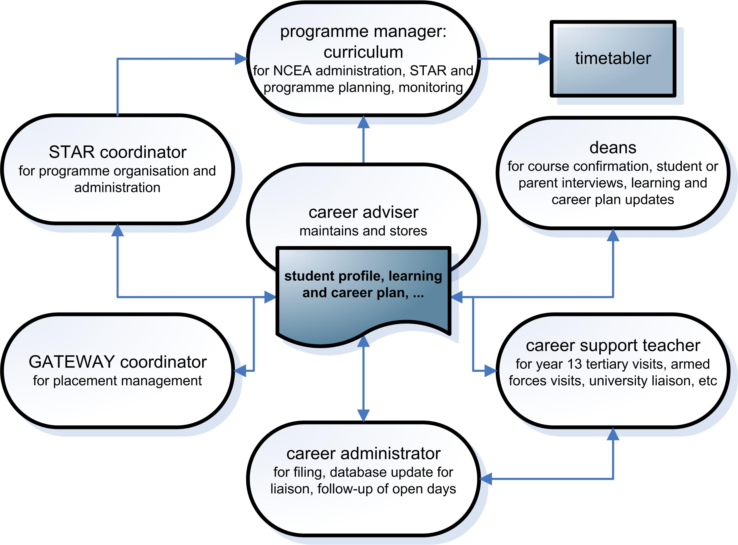

Monitoring

Teachers need to be alert to students who may need extra help with learning and career planning, such as those:
  - who do not have goals
  - whose goals do not reflect the interests and strengths they have identified
  - whose goals do not reflect their achievement so far.
There are some suggestions for responding to these situations in the table below. Students can be referred for guidance if necessary.

Situation | Possible response
Students find it difficult or are reluctant to identify their own strengths | Employ other strategies such as getting peers to comment on each other’s strengths
Students are reluctant to set long term goals – they fear committing to one path | Refocus the student on options around a range of career choices
Students have unrealistically high goals | Explore what is involved in the desired job(s) and the study required to enter them. Question the student to ascertain their capabilities
Students have unrealistically low goals | Explore a range of low-skilled jobs. Question the student as to whether these are the type of job they really aspire to
Students are fixated on one job | Encourage the student to explore other options or look at job families rather than one job
Students are not well engaged in school | Involve in alternative curriculum and out-of-school activities such as expos, work experience or shadowing

Learning and career planning and subject choice

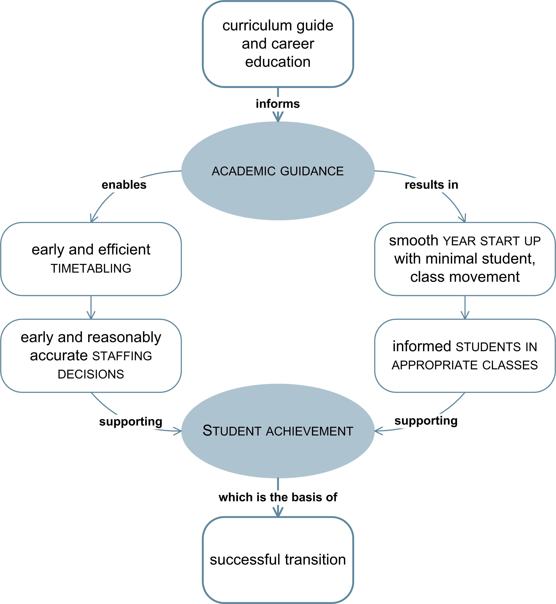

Informed decision making – the key
Subject choice is an important career-related event in students’ lives. For students to make informed decisions that will maximise their opportunities to reach their future potential, the process must rest on opportunities to develop career decision-making knowledge and skills.
Schools provide these opportunities in a variety of ways: some schools integrate the process with career programmes that lead into subject choice, while others run a week’s careers pathway theme prior to it.
It is important to provide these opportunities every year. Many students will have had some introduction to subject choice in their intermediate and junior high school years, but others may have missed out or forgotten the information they were given at that time.
Academic guidance – the process
Most staff are involved in the subject choice process in some way:
  - subject teachers give information and advice about their curriculum area and subject pathways
  - deans and form or whānau teachers use their knowledge of students’ to help them assess the appropriateness of their choices
  - the careers team provide expert or more in-depth guidance.
Students need assistance with subject choice. To assess what type of assistance individuals may require, many schools use a simple pathway planning sheet that asks students to:
  - consider the pathways open to them
  - indicate how confident they are about making a decision on their next step and what information and assistance they need.

Matching exploration and curriculum options to career ideas

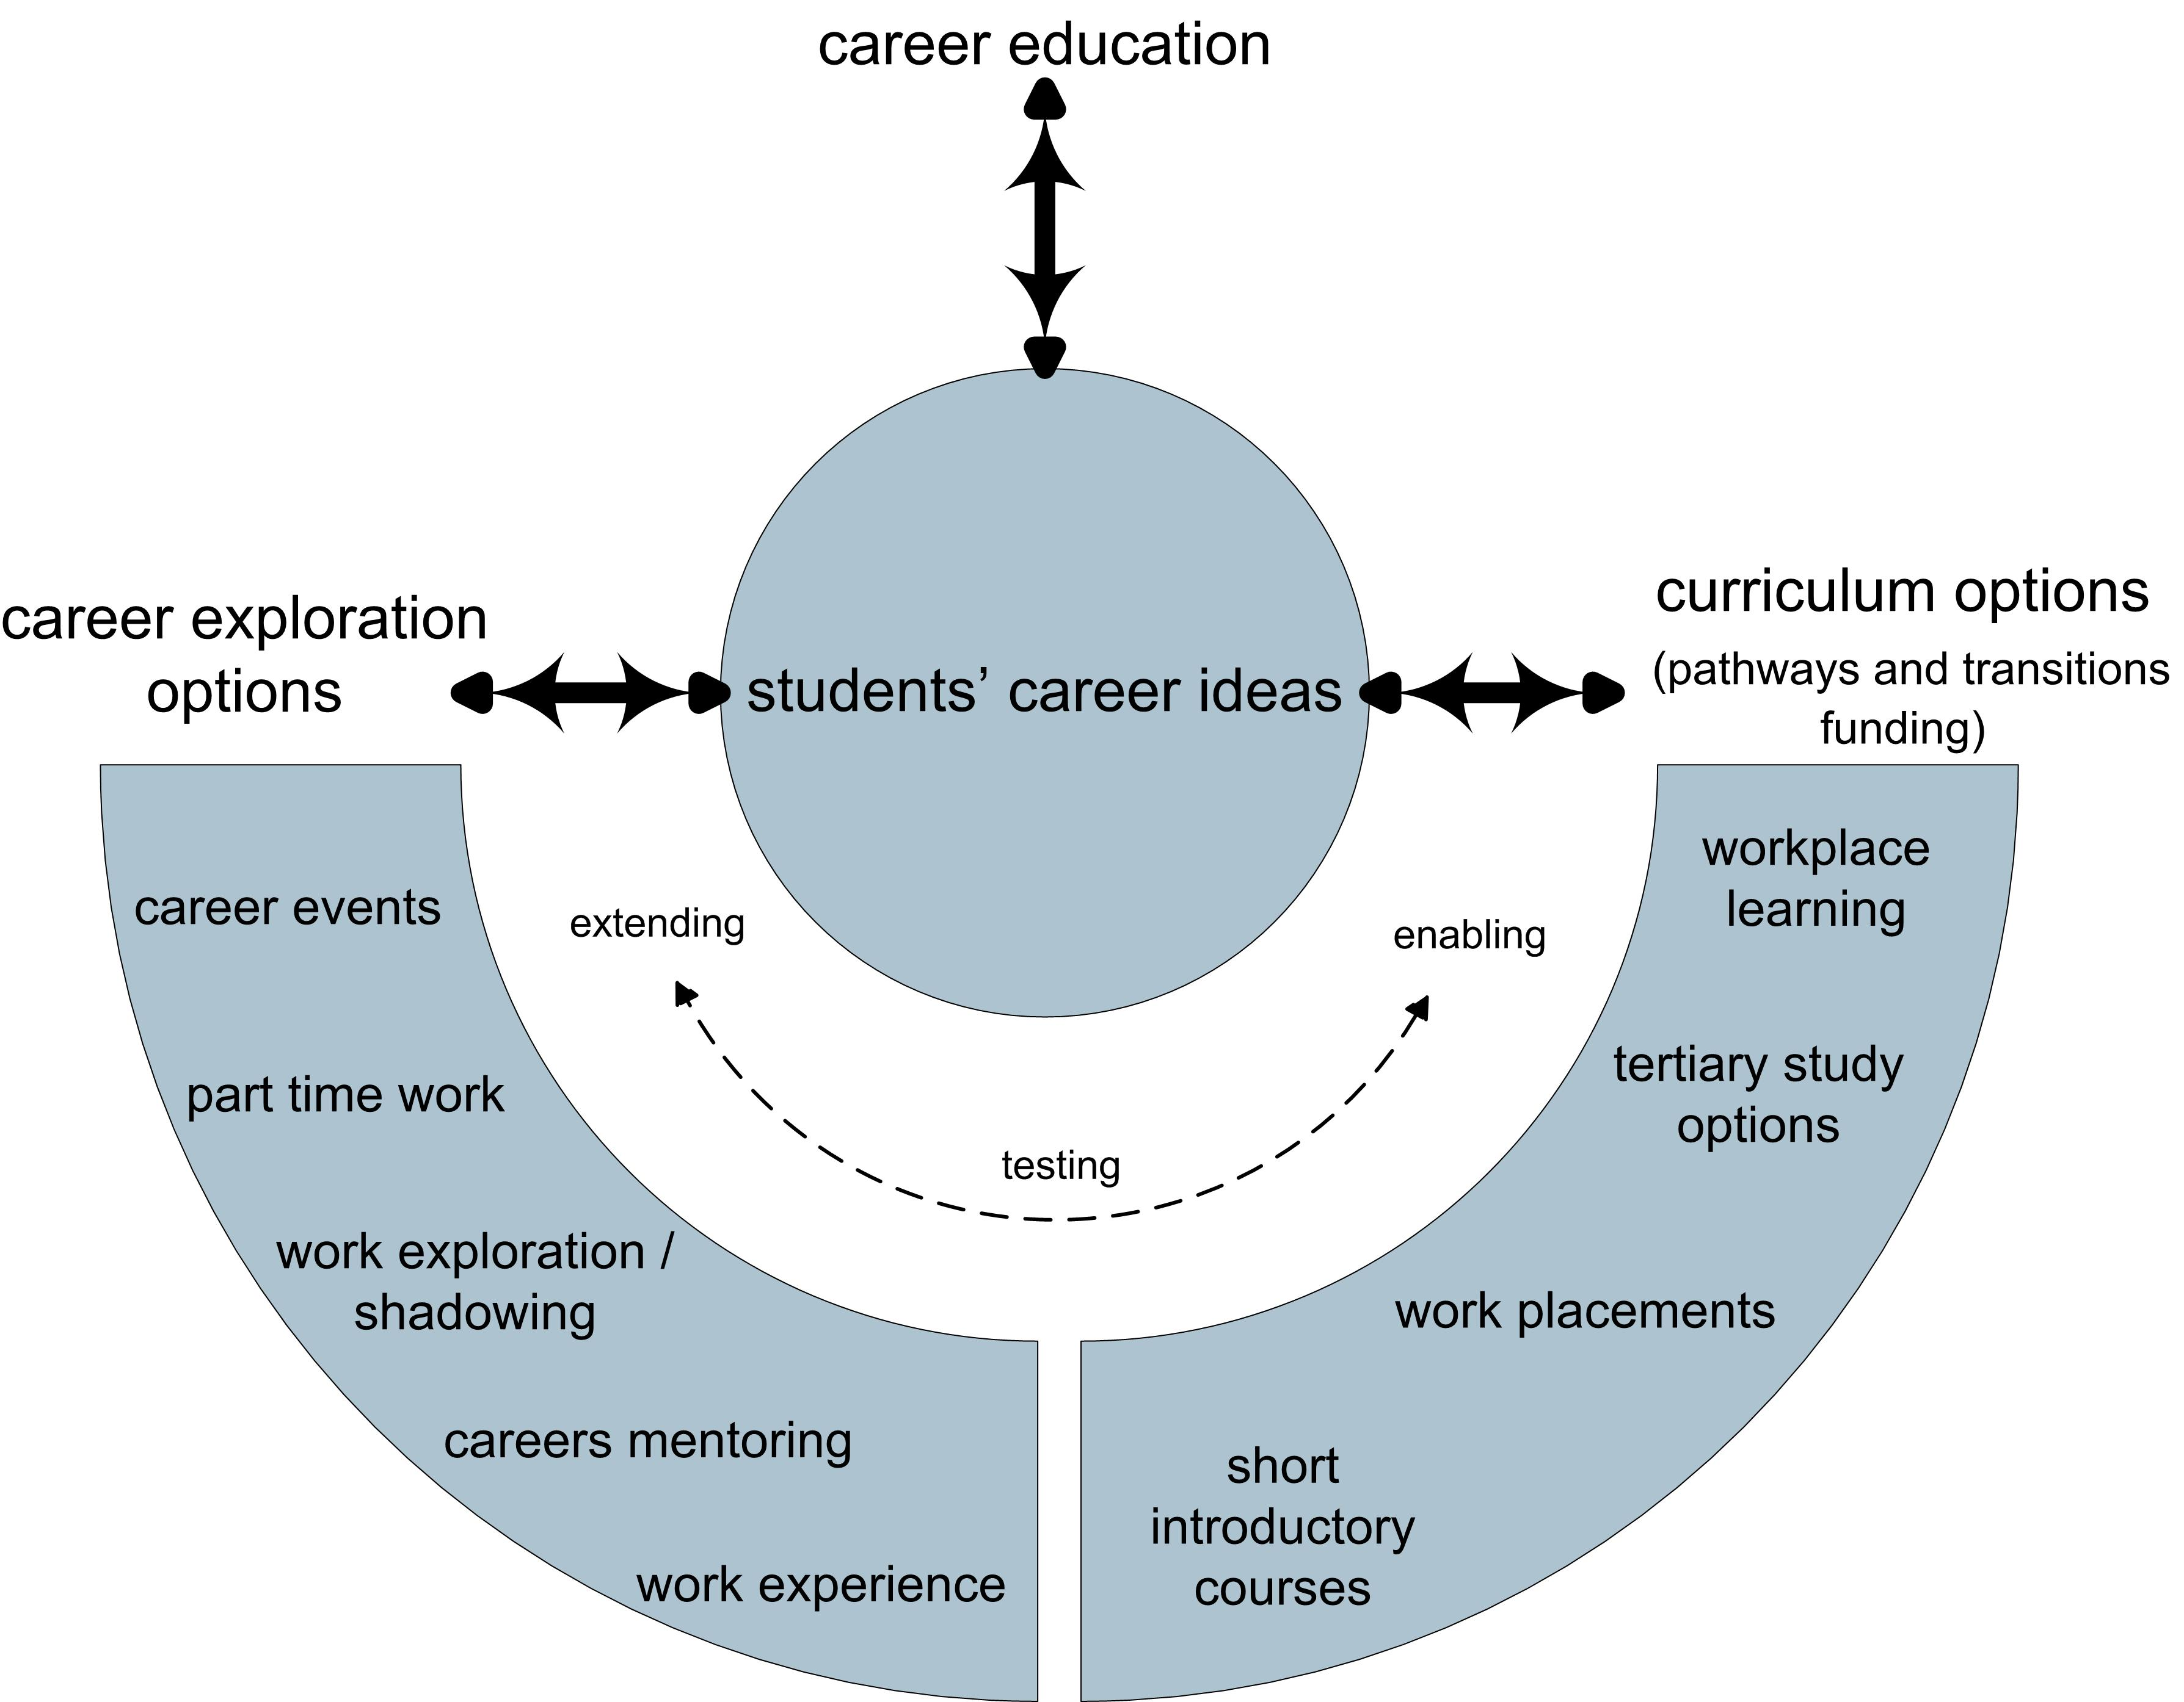

Why do this?
  - to provide opportunities and experiences that are most relevant to an individual
student’s stage of career development and potential career direction
  - to maximise effectiveness of time spent planning and organising these activities
  - to maximise effectiveness of pathways and transitions funding (eg. STAR and Gateway).
What does it take?
  - a career education programme that builds awareness of self and opportunities
  - flexible database(s) that allow analysis of students’ career ideas and achievement data
to identify curriculum and career exploration needs
  - processes and systems that incorporate the results of this analysis in curriculum design
  - ongoing measuring of outcomes of these activities in order to enhance them and the
selection criteria for them, and to generate ideas for new activities.

Part 3 : CPaBL project
This section draws on the findings of the evaluation conducted by the Education Review Office on Creating Pathways and Building Lives (CPaBL), a two-year project (2007-2008) in 100 secondary schools to increase capability and capacity in delivering career education.

Purpose
The CPaBLproject was intended to:
  - improve the quality of careers education and guidance
  - improve student motivation, engagement, retention and achievement
  - assist students in making a smooth transition from school to further training and employment
  - be more responsive to diverse student needs, specifically those of Māori, Pasifika, refugee and migrant students, and students unprepared for transition
  - encourage the involvement of families and whānau in decisions about their children’s career pathways.
Approach
The key ‘tool’ used for achieving the project intentions was school-wide career education planning and delivery.
The aim of career education planning is to build a foundation for the sustainable delivery and ongoing development of career education and guidance.
To build school-wide involvement in career education planning and delivery the project encouraged the establishment of a careers lead team with representatives from across the school.
The project assisted these teams to take an evidence-based approach to career education planning. This began with the collection of baseline data at the start of the project.

Outcomes

The final evaluation reports on the project find the project met the intentions.
The benefits observed for the career education planning approach include:
  - clarifies the school’s understanding of career education and how it fits with pastoral care, curriculum areas and processes such as subject choice
  - links career education with the school strategic plan and self-review cycle
  - supports informed decisions about where aspects of career education best fit with the school’s curriculum and structures
  - sustains developments in career education.
The benefits observed for the careers lead team approach include:
  - builds recognition that career education has a valuable role in enhancing student motivation
  - enables inclusion of a broader range of views and approaches
  - lifts profile and facilitates broader understanding and uptake across the school
  - shares tasks and responsibilities for ongoing development, monitoring and review of programmes
  - increases the likelihood that positive developments will be sustained.

Developments and trends

The processes and structures schools developed during the project saw some practices emerging more strongly:
  - Schools have a greater appreciation of their role in developing pathways for students and in helping them to achieve the goals they set.
  - Schools are including career education and guidance in tutorial or form time, recognising that students need more personalised support from someone with whom they have an ongoing relationship. This expansion in the tutor/form teacher role does not mean taking on the role of the careers adviser. The tutor/form teachers’ skill is to know when to refer students for careers advice.
  - Processes for subject choice are being strengthened. Increasingly schools are setting up a process where each student’s subject choices are checked against likely career intentions. Subject choice meetings are now more likely to include careers advisers, tertiary providers and sometimes employers, such as the armed forces.
  - Schools are increasingly aware of the value of goal setting as a means of motivating students. Some offer open days for parents, together with their children, to meet teachers to discuss students’ strengths, goals and possible pathways towards those goals. The goals, and progress towards the goals, are often documented in a student profile or development plan.
  - Schools are developing student profiles, with many schools recording pathways information on student management systems and encouraging staff to access appropriate information about the students they are teaching.
  - Teachers are talking about jobs where the subject might be used, explaining the relevance or long-term value of learning a particular topic, or using career education as the focus for teaching a skill such as information literacy.

“One school closed for lessons for the day and each tutor teacher was allocated students to work with. The tutor teachers were informed of the purpose and expected outcomes of the exercise, given resources, and trained by the RTLB in interview skills and in how to relate to parents.
The parents were sent personal letters of invitation and allocated 20 minutes uninterrupted to meet the teacher with their child to discuss the student’s strengths, interests and values. The times scheduled went from early morning to 9pm to cater for parents’ work commitments.
The parents talked with their child about how long they would continue at school and what they wanted to do. The goals were recorded and each term the form teacher reviewed them with the student and the results were sent to the parents with their reports. Teachers were surprised at the level of interest the parents showed and the desire the students had to involve their parents.” (ERO, 2009)

Some of the needs that continued to be observed during this project include:
  - Schools need to continue to develop staff understanding of planning for student outcomes and their skills in self review.
  - Schools need to focus career education professional development to encourage staff to see their role more broadly, help them to recognise that a key function of the school is to provide a pathway for students to transition from the school to work or further education, and emphasise the importance of relationships for effective teaching.

References

Aatea Consultants Ltd. (2005), Review of Career Resources for Māori: Stakeholder Feedback, prepared for Careers New Zealand, Wellington
Boyd S., McDowall S. & Ferral H. (2006) Innovative Pathways from School: Taking the first step: Final report, New Zealand Council of Educational Research, Wellington
Dusseldorp Skills Forum and Career Education Association of Victoria (1996) Career Education and Guidance for the Next Millennium, Dusseldorp Skills Forum, Melbourne
Education Review Office (2006) Evaluation of Designing Careers Pilot, Ministry of Education, Wellington
Education Review Office (2009) Creating Pathways and Building Lives: CPaBL in Action, Ministry of Education, Wellington
Education Review Office (2009) Creating Pathways and Building Lives: Overall Evaluation of the Initiative, Ministry of Education, Wellington
Ministerial Council on Education, Employment, Training and Youth Affairs (2009) Australian Blueprint for Career Development, Australia, www.blueprint.edu.au
Ministry of Education (2009) Career Education and Guidance in New Zealand Schools, http://nzcurriculum.tki.org.nz/
Ministry of Education (2009) Transition to Secondary School: Does it affect age-16 performance?, Competent Children, Competent Learners series, www.educationcounts.govt.nz/publications
Ministry of Education (2008) A Study of Students’ Transition from Primary to Secondary Schooling, www.educationcounts.govt.nz/publicationsg
Ministry of Education (2006) STAR: A Guide to the Secondary Tertiary Alignment Resource, Learning Media, Wellington
Ministry of Pacific Island Affairs (2003) Ala Fou – New Pathways: Strategic Directions for Pacific Youth in New Zealand, Wellington
Organisation of Economic Co-operation and Development (2000) From Initial Education to Working Life: Making Transitions Work
Vaughn, K. & Boyd, S. (2004) An Evaluation of Youth Pathways, New Zealand Council of Educational Research, Wellington
Watts, A.G. (2006) Career education in schools: an international perspective, CEAV Newsjournal. February 2006, pages 21–28
Watts, A. G. & Sultana, R. G. (2003) Career Guidance Policies in 36 Countries: Contrasts and Common Themes, paper for CEDEFOP conference on Career Guidance and Public Policy: Bridging the Gap, Toronto, Canada, October 2003

Appendices

Appendix 1 : Common themes by year level
Appendix 2 : For first-time careers advisers
Appendix 3 : Example themes and questions for questionnaires
Appendix 4 : Checklists to assist planning and review

Appendix 1 : Common themes by year level

Year 7 – Self awareness  - Who am I? What are my interests and hobbies and what skills do I learn from them? | Year 8 – Self awareness and transition  - Who am I? What are my skills, talents and abilities?  - Transition to secondary school, subject choice
Year 9 – Self awareness  - Orientation to secondary school  - Who am I? Where do I want to be? | Year 10 – Work in a changing world  - What is work about? What might it mean for me?  - The Real Game, career information research, learning and career planning, subject choice, work experience for a day, short STAR activities
Year 11 – Exploration of work and training  - How can I start to prepare for a successful future?  - Specific career information and research, subject choice, CV writing, interview skills, personal development, study skills | Year 12 – Exploration, planning and action  - How can I explore and clarify my ideas for my future?  - Tertiary education and training information research, STAR activities, work experience, job search skills, transition classes, Gateway courses
Year 13 – Planning and action  - What definite steps do I need to take to continue to be successful post-school?  - Tertiary education and training planning, work experience, individual programmes, transition classes | All year levels  - Engaging parents (through report evenings, career evenings, …)  - Engaging community (visiting speakers, education outside the classroom, …)  - Engaging students (role models, change management skills at transition points: school-to-school, school-to-work, school-to-tertiary, combining school and work; information gathering skills, encouraging independent career exploration, reinforcing the ongoing nature of change in the world of work)

Appendix 2 : For first-time careers advisers
If you have been given the role of careers adviser in your school, and are unsure of where to begin, this will give you some ideas of where to get started.

Framework
  - Read the Ministry of Education publication Career Education and Guidance in New Zealand Schools (2009). This is on the New Zealand Curriculum website at
http://nzcurriculum.tki.org.nz/Careers
  - Locate the current management and related documentation for career education and guidance. This may include your school’s policy or charter, career education planning documents, the latest ERO report, recent reports to the board of trustees, and delivery plans.
Role
  - Discuss with the principal the board and school management’s vision for career education at your school.
  - Clarify with the principal what structures there are or will be to support implementation of career education across the school.
  - Get a copy of your current job description and identify who reports to you and who you report to.
  - Find out what the budget is and contact the finance administrator for information about systems for invoicing, ordering and paying for resources and services.
Personnel and networks
  - Identify the people in your school who have responsibility for overseeing career education and guidance, facilitating career education delivery across the curriculum, coordinating STAR, Gateway, transition education, work experience, the guidance network, and providing administrative support. Find out who previously held these roles.
  - Contact your local Careers New Zealand centre (0800 222 733) to find out who the liaison is for your school and when an induction course for careers advisers will be held.
  - Identify the help available from your local School Support Services team.
  - Contact your local Career and Transition Educators (CATE) representative, www.cate.co.nz. Arrange a buddy system with an experienced careers adviser from another school.

Career information and resources
  - Get to know what is offered on the Careers New Zealand website (www.careers.govt.nz) and through the advice line service.
  - Identify appropriate career education resources for years 9-13 and become familiar with these.
  - Identify and diary the dates of key career-related events and responsibilities for the coming year.
  - Become familiar with the range of training and study options available from tertiary providers.
It will also be helpful to find out:
  - who in the school management team does or might help champion career education.
  - who has experience and expertise in delivering aspects of career education and guidance, both from within the school and from outside the school.
  - what existing links there are with the community, employers, tertiary providers, Industry Training Organisations (ITOs), and local service organisations.
  - whether you are receiving the Careers New Zealand newsletter to schools. This is sent in the first 2 weeks of each term.

Moving forward

You may need to consider some of the following actions once you have settled into your role:
  - consult with curriculum and pastoral care leaders to explore what links exist to career education in their areas and what opportunities there are for further development
  - use effective practice criteria to assess the quality of the current provision of career education and guidance in your school
  - meet with your manager, the principal and/or the school management team to discuss your review conclusions and agree possible next steps
  - organise and deliver a professional development session with all staff to report on your review and set out plans. It is a good idea to:
- get the active involvement of the principal and school management team in the session
- clearly link career education goals and plans to your school’s goals and strategies
- consider using a quick questionnaire to get an idea of individual teacher’s interest, confidence, needs, etc.

Tips for surviving your first year

  - Prioritise tasks to improve career education and guidance in your school, and break large tasks into smaller ones.
  - Recognise that you can’t do everything yourself: build your team.
  - Note down new ideas gleaned from other careers advisers.
  - Keep a copy of all resource material you acquire from other sources.
  - Develop good networks: with other careers advisers, with Careers New Zealand, CATE and CPANZ contacts, and so on.
  - Don’t be afraid to ask anybody for anything.
  - You need some hours in the day for rest and relaxation outside of school.

Appendix 3 : Example question areas for surveys

Students
To measure how often students have had opportunities to develop career management competencies and how much they’ve taken from these | How often do your teachers include information and activities related to the following topics in classes?
 | How much have you learnt about the following topics this year?
 | Who has helped you most with information about what you might do when you leave school? (eg. careers adviser, dean, teacher, parents, other)
 | The career management competencies will suggest other topics for these questions.
To measure which programme elements, activities and services students find helpful | Which of the following have you found most helpful for planning your future? (rank in order)
 | How useful has each of the following sources of career information been to you?
 | How easy is it to get the information you want?
To measure how well you are supporting students overall | Do you agree or disagree with the statements below? (eg. ideas and beliefs about learning, working and career amongst students that you are instilling or countering)
To measure how well you are supporting students overall | How confident do you feel about …  (eg. a next step or a list of things students need to understand or be able to do)?
To measure how well you are supporting students overall | How well has the school helped you to…? (eg. choose subjects, courses, plan for a future career)
To find out about students’ planning | Do you talk to your family or whānau about …  (eg. a next step or ideas for their future)?
To find out about students’ planning | How long do you think you will stay at school? What do you think you will do when you leave school?
To find out about students’ planning | If you are about to leave school, have school staff helped you with any of the things listed below? (yes/no, I’d like help/no, I don’t need help)

Teachers
To measure the extent to which teachers include career-related information and learning | How often do you include opportunities in your classes to explore the following? (eg. relevance of skills and knowledge to students’ futures, related courses, jobs and careers, students’ knowledge of themselves)
 | How much do you know about the career aspirations of the students in your classes?
To measure teachers’ confidence | How confident do you feel to …? (eg. from basic subject-related to more complex possible contributions to career education in the school)
To measure teachers’ confidence | Would you be interested in attending professional development on more effective ways to provide career relevancy to your subject?
To measure teachers’ views of career education as a whole | What are the good things about career education in your school?
To measure teachers’ views of career education as a whole | How could it be improved?
Parents
To measure families’ views on the information provided | How useful is the information about courses and careers in the school’s …? (eg. course information book, website)
To measure families’ views on the information provided | Have you attended any meetings at school where you got information about courses and careers?
To measure families’ views on the information provided | Has the school provided enough information for you to help your child choose courses and possible career options?
To measure families’ views on the support provided | To what extent has the school involved you in … (eg. subject choice, placement in courses)
To measure families’ views on the support provided | Who has helped you support your child’s planning and decision-making?
To measure families’ views on the support provided | How satisfied are you with the support to help your child plan for possible courses, study or jobs?
To measure families’ views on the support provided | What else could the school do to help your child explore possible courses and careers?

Appendix 4 : Checklists for planning and review
Checking how well you’re doing
Leadership | What do we see now? | How to be more effective? | What support is needed?
Our principal demonstrates a commitment to career education
Our teachers understand the role and value of career education
Our school management systems support a school-wide approach
Our school-based curriculum planning considers students’ career ideas
Our school fosters a culture that values all pathways and aspirations
Our school has a dedicated area for a career centre which is accessible to all
We maintain links with our community that support effective transitions
Other:
Checking how well you’re doing
Planning and review | What do we see now? | How to be more effective? | What support is needed?
Career education is led by a cross-school team with senior management representation
Our planning identifies and analyses the needs of all groups of students
We consult and inform staff and the school community as part of our planning
We are working to a plan for developing career education
We consider current and future resource needs (staff, PD, budget, etc) in our planning
We are regularly evaluating and reviewing our career education
We are reporting our activities and highlights to the principal, board and school community
Other:

Checking how well you’re doing
Design and evaluation | What do we see now? | How to be more effective? | What support is needed?
We link our activities to career-related events in students’ lives
We provide opportunities for all students to develop the relevant career competencies
We have targeted activities to meet the needs of specific groups of students
We provide a range of different kinds of learning experiences
We make use of outside people, resources and experiences
We encourage family and community involvement in appropriate ways
We are gathering the right evidence to guide our review processes
Other:

Checking how well you’re doing
Management and delivery | What do we see now? | How to be more effective? | What support is needed?
We assist staff to understand how they can make a contribution to career education
We provide support to teachers to develop their knowledge and confidence
We have written policies, programmes and other documentation
We maintain and share appropriate student information
Our school’s website and core publications include information on careers
We make career information accessible to students, parents and caregivers, and staff
We ensure career information and career resources are current, accurate and suitable
Other:

Meeting the needs of students at risk of successful transitions
 | how well? | evidence
Understanding the social, cultural and employment backgrounds and perspectives of specific groups of students in the school
Gathering and analysing evidence on students’ attendance, achievement, career ideas, intentions, etc to inform curriculum and programme design
Building a culture where staff acknowledge they all have a role in helping students to make successful transitions
Providing training and materials for staff to help them to recognise when individuals may need career guidance and what to do in these instances
Planning and delivering programmes to widen horizons, encourage aspirations and demonstrate the relevance of school and education
Responding quickly to students who appear to be less motivated to take part in learning and who do not respond well to school codes of practice
Predicting when individual students are nearing the end of their schooling and ensuring they do not leave without full consideration of all the options
Looking for students with diverging areas of interest and strength and helping them make informed choices
Implementing recording and reporting systems which all staff can access, and a well-supported referral system which includes careers staff
Systematically following up these students and regularly checking on their progress
Communication strategies
audiences |  | students | teachers | families | comm.-unity
information sharing | School newsletters, magazines  School website, lobby displays  School charter and prospectus  Course booklet / curriculum handbook  Local media: print, radio  Community, church and club noticeboards  Personal invitations to events (by phone, etc)  Sending home relevant career-related brochures
school events | Student enrolment and induction  Year level parent forums  School expos or careers evenings  Subject choice evenings  Report / parent interview evenings  Career centre open days or evenings  Student career interviews  Community involvement in career activities  Family / community career workshops
other activities | Surveys to seek community perspectives  Having a career education advisory group  Meeting with parent groups, runanga mātua  Presenting to business or service groups  Community thank-you events  Business @ school days, Dads and Boys days…  Briefings for local journalists, eg on NCEA

Award Scheme Development and Accreditation Network is an activity based programme developing personal and social skills within a variety of contexts.

