**What is a think board?**

Think boards allow students to visually represent their thoughts and ideas on a subject. Students can then find links between these thoughts and ideas.

**Think board example: camera**

Here is an example of using a think board to link different ideas and thoughts around the concept of the camera.

**People:** Who uses this? Who does this affect?

**Skills:** What skills do we need to use the subject?

**Symbols:** What are the common symbols related to the subject?

**Jobs/careers:** What jobs would use the subject?

**Visual representation:** What images represent the subject?

.

**Subject**



**Jobs/careers**

Film/TV operator

Photographer

Film & video editor

**Symbols**

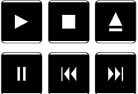

**People**

All of us: cellphone and camera owners

**Visual representation**

 



**Skills**

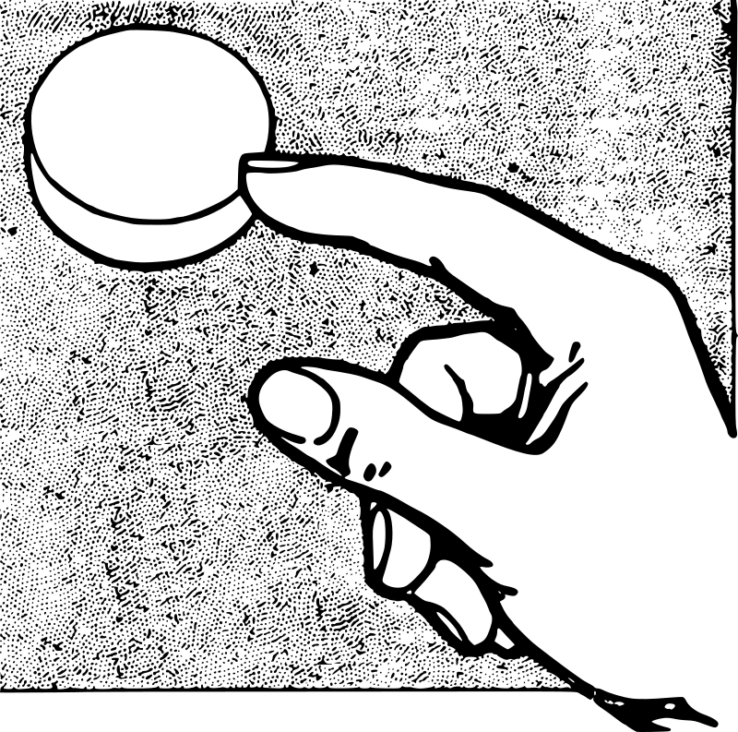

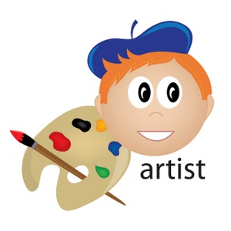

Acknowledgement: Whaea Rona Mulligan, senior teacher of the Senior School and Year 7 and 8 teacher, Tairangi School, Porirua.

**Skills**

**Visual representation**

**Jobs/careers**

**Symbols**

**Subject**

**People**