Understanding
career education
in years 7 and 8



August 2009

Careers New Zealand © 2009
Published by Careers New Zealand, PO Box 9446, Wellington, New Zealand
Permission is granted to reproduce this document in whole or part for non-commercial career education purposes, as long as the source is acknowledged.
Except as permitted under the Copyright Act 1994 or any copyright licence, no part of this document may be reproduced for other purposes without the permission of Careers New Zealand.

This guide is available as a downloadable PDF from the Resources and Brochures section of Careers New Zealand website, www.careers.govt.nz.

Contents

What is in this guide 2
Career education at years 7 and 8 3
Overview 3
The language of careers 3
The focus at years 7 and 8 4
Teacher-student interactions: valuing the individual child 7
Learning about transitions 10
Understanding career education at year 9 and above 14
Making it happen 15
Overview 15
National Administration Guidelines 16
Leadership and profile 17
Strategy and planning 20
Management and delivery 23
Relationships 28
Getting started: for new careers leaders 32
References 34
Appendix 1: Checklist for reviewing progress 35

What is in this guide
This guide introduces career education at years 7 and 8: what is appropriate, why and how.
This guide is for:
- school managers and teachers in years 7 and 8 who are responsible for leading the planning and implementation of career education in their school
- all teachers in years 7 and 8 who want to understand how career education will help them meet the needs of their students in years 7 and 8 and prepare them for transition to secondary school.
It should be read in conjunction with the Ministry of Education publication Career Education and Guidance in New Zealand Schools (2009). It is a companion document to Career Education in Practice (Careers New Zealand, 2009), which is useful to all schools but weighted towards approaches and environments in secondary schools.
The content in this guide was developed through discussions with primary, intermediate and secondary schools. Careers New Zealand would like to thank all the schools that gave their time and shared their knowledge with us.

Feedback
We welcome your comments and additions to this guide. You can pass on your feedback to any Careers New Zealand consultant or to the career resources publication team. Our contact details are:
freephone: 0800 222 733 email: careers@careers.govt.nz

Career education at years 7 and 8
What is in this chapter
This chapter aims to help you understand how career education is relevant to children at this stage, what kinds of discussions and activities are appropriate at these year levels and how these prepare students for transition and lead on to career education in their later years of schooling.
Overview
When a 12 year old child says “I’m good at fixing things, I could be a mechanic”, it is a realisation, not a decision.
Career education at years 7 and 8 is directed towards students gaining the skills, understandings and experiences that form the foundations of future successful career management. It is not directed towards making decisions or choices about future careers.
Children of this age are learning to make connections between their own strengths and interests and the jobs that they see and learn about. The ability to make these connections and become more self-aware can be supported by others (eg. teachers, parents, peers) providing them with explicit feedback and therefore reflecting the skills and qualities they demonstrate.
Children of this age are also developing the self-belief that future jobs are possible for them. A sense of competence and of the ability to accomplish new tasks successfully are important developmental milestones of this stage, fostering motivation and confidence towards achieving new and future goals. This is an important stage in becoming aspirational.
The language of careers
“Our parents and students don’t relate to the word ‘career’. We use ‘future’ to inspire them.”
Words such as ‘future’ are a good substitute to use in everyday language to inspire and motivate children, particularly with groups where the word ‘career’ has little meaning or people feel it doesn’t apply to them.
An appropriate task at years 7 and 8, however, is to introduce the word ‘career’ in its current meaning – not as something just for professionals, but as a word that applies to all individuals. Familiarity with this meaning and a growing comfort with the word will ensure students feel more included in later secondary school experiences where the word ‘career’ is commonly used.
Likewise, learning the language of the skills used in work helps students to understand these concepts and to be able to apply them to themselves when taking part in career education activities and reflecting on their strengths, and in the future when writing CVs.
The focus at years 7 and 8
At this stage, students need opportunities to:
learn:  - to question self and others about learning options, jobs and work  - to explore by researching, information gathering, finding and using resources about areas of interest and the working world  - how to plan and prepare for change and transitions | skills
develop awareness:  - of their own growing skills, strengths and interests, their unique self  - that there are connections between people’s abilities and interests and the careers they choose  - that people’s skills are built up over time through ongoing learning  - that planning is important and people plan over time to achieve learning goals and future careers  - that there are actions that help people cope with change and transitions | understandings
be exposed to:  - a range of learning and work situations and jobs to broaden understandings of the world of work  - a diversity of people and jobs to help in valuing all types of work, understanding hidden complexities in work, and reducing stereotype and gender beliefs  - the stories of individuals and their careers to help understandings of how people become what they are, why adults have different roles. | experiences

Career competencies at years 7 and 8
Developing self-awareness  Students demonstrate  - the ability to ask questions of self:  What am I good at? What am I improving in?  What skills am I developing?  What do I like best? What interests me most? | Students can  - talk about their strengths and identify positive aspects of themselves  - state aspirations and a vision of a future  - express goals for change and growth
Exploring opportunities  Students demonstrate  - the ability to ask questions of others to increase awareness:  What skills are used in your work?  How did you get into that job? What did you have to learn?  - an understanding that jobs, opportunities and choices are related to an individual’s skills, abilities and interests:  What abilities might this person have had when they were growing up?  What activities must they like to like this job?  What other jobs could they do? | Students can  - connect educational achievement with people’s ability to choose options  - connect a learning path to occupations that are investigated  - use websites and other resources to gather information on careers and jobs
Deciding and acting  Students demonstrate  - an understanding that exploration and gathering information assists decision making and planning:  What would you have to find out about before you choose a job?  How could you plan to make a good move to secondary school?  - an understanding of how to prepare for a major transition (moving to secondary school):  What do I need to know?  Who can help me? | Students can  - explain decisions and choices they have made  - write personal goals and plans for future progress  - relate family ideas and actions to their goals and plans  - prepare for change by gathering information about the new environment and sources of help  - complete documentation about self (eg. a portfolio, taonga file)
Ways that career education develops the key competencies
Key competencies | Career education context
Managing self | - developing and maintaining self-esteem and self-belief  - developing and broadening aspirations beyond stereotypes  - developing new skills and a sense of competence  - understanding change and growth as part of life  - learning how to set goals and make plans
Relating to others | - developing skills for positive interactions with others  - listening to others’ experiences of goals in learning and work  - recognising the work roles of others and valuing these  - learning different styles of interaction for new situations
Participating and contributing | - understanding contribution to society through work  - understanding how school and participation in learning relates to future life roles  - developing a vision of self in the future world of work  - valuing connections to community
Thinking | - learning to think about the future  - recognising the broad scope of work now and in the future  - developing an understanding of what is involved in decision making
Using language symbols and texts | - learning the language of careers, the vocabulary of skills  - researching information about work and careers  - communicating knowledge and ideas in appropriate ways

Teacher-student interactions: valuing the individual child
The ability to dream and to grow aspirational ideas about oneself is key. Children need to be able to imagine themselves as happy, successful, important, creative, … It is not about having the ‘right’ dream or aspiration. When you foster the dreams of even very young children, you foster their confidence and self-belief. (Carpenter, 2007)
➢
When you encourage dreams, you encourage self-belief, a necessary factor for achievement.
- Students share dreams and aspirations with teachers as part of developing a view of themselves in the future and beliefs that they are able to ‘be somebody’. They are developing dreams of their future selves and they will adjust dreams to their realities as they mature.

Hope is an essential factor, especially for children at risk.
- Hopeful thinking by children allows them to set goals and to work towards achieving those goals. Teachers encourage hopeful thinking by communicating a positive view of students’ ability to have a future and faith in their ability to achieve their goals.

Connecting their realities to future possibilities gives them hope and encouragement that they have a future.
- A teacher noticing drawing and cartooning skills in an individual child makes the child and his classmates aware these are a valuable talent and cartooning skills have a potential work future. This is exciting news for a child who discovers his talents may connect to work.
➢
Research has suggested that hope is associated with the successful handling of challenging life events. Hopeful youth expect good outcomes and have more positive and longer-term goals. For high-risk children hope functions as a powerfully protective factor, in the sense that aspirations can be enhanced by hopefulness. (Kabir & Rickards, 2007)

Engaging students by using their own lives to teach them about skills
Adapted from a presentation by Gray Poehnell, 2007

Purpose
In this exercise, students are asked to tell a story about themselves and taught how to reflect (‘What kind of person do you think…’) and self discover by using the story to illustrate attitudes and skills. The key is to engage the student in the process, so start where the student is engaged, in life!
Process
You could start the exercise by asking students to make a list of up to ten of their favourite things. Then ask a student to choose one thing from his or her list to talk more about.
The story
Ask a student to tell a story – it has to be specific; a particular experience that was a good experience. For example, rather than ‘I enjoy skateboarding’ they need to tell you of a particular experience they have enjoyed, for example, ‘I enjoyed learning a new flip trick’.
As they tell their story, write it up on a chart or whiteboard. Put the story in their language and by-pass any negative self-talk, writing up the positive. A technique that may help them talk about their story is the use of STAR (situation, task, action, results).
Use questions to help them talk about their experience and how it relates to the world of work. For example:
- I couldn’t do that. What would you have to do in order to be able to do that? (skills and assets)
- What did you particularly enjoy? (interests)
- What were the challenges? (dealing with difficulties and challenges)
- When did you start? Have you always…? (developmental perspective)
- What did people think? Did anyone help you? (others’ perspectives and allies)
The reflection
On a new chart, do the reflection ‘What does this say about you as a person?’ The idea is to teach them the skill of reflection – this gives them ownership and helps them to discover their skills. (You want them to be surprised at what they have.) You are teaching them how to connect to the world of work by identifying the skills a child is using in a particular activity; you are also teaching them the language of skills that are used in the world of work, a very important learning vocabulary.

Example: perfecting a particular flip trick (skateboarding)
The student’s story
- started off learning smaller tricks with the aim of building up his confidence to try something harder | This demonstrates planning and goal setting
- wasn’t happy with his initial board. Tried a couple of different boards and also loosening the trucks underneath until he felt comfortable with the way he was turning | This demonstrates problem solving
- got on to the internet and searched for videos of people doing the flips and also read about the tricks and techniques they used | This demonstrates research skills
- practised hard on getting the right balance – leaning forward or backward or bending knees – in order to be able to stay on the board without too much trouble and handle a fall without too much damage | This demonstrates coordination, practical skills
- after each attempt that failed, looked at how he made his approach, distance and angle, and made adjustments | This demonstrates mathematical, analytical and process skills
- practised every day after school until he got it – determined not to give up | This demonstrates motivation and perseverance
- enjoyed being able to show off to his mates what he had done and then spent some time teaching one of them how to go about doing it, encouraging him to keep trying, especially when he kept falling | This demonstrates ability to motivate others, provide instruction

Learning about transitions
The ability to handle change and transition is a core career management skill needed throughout life. It helps people to handle the challenges and be open to the opportunities of new situations or environments. Providing students with opportunities to develop this ability is fundamental to career education in schools.
Many year 8 students find the transition to secondary school a daunting prospect. Learning activities at years 7 and 8 that focus on the importance of change and growth as a part of life will help students develop coping skills to handle this transition as well as equip them for their future and a constantly changing world of work.
Years 7 and 8 students have already experienced transitions. They have started school and many have moved schools; they may also have gone through transitions in other areas of their life, for example, pubertal change and changes in family dynamics. So they have experiences to contribute and learn from which can be reflected on in discussions about strategies for coping with change.

What teachers can do
- encourage a positive approach to the change to secondary school: positive messages help to increase motivation and confidence
- encourage optimism and self-belief in students’ capacity to manage this change, while giving them some tools (eg. problem solving and coping strategies)
- prepare them for what they can expect in the new environment.

Skills that help year 8 students cope with transition
- communication: the confidence and ability to ask questions, initiate conversations, ask for help
- self-management: preparing for more responsibility in managing books and resources, and adjusting to new rooms, teachers and timetables
- using support systems: knowing or finding someone already in the new school who can explain, answer questions and provide help.

Research from the AIMHI (Achievement in Multicultural High Schools) project indicates that these are particularly important for Māori and Pasifika children facing transitions. ‘Many of them enter secondary school expecting it to be a difficult and unfriendly place. While it is important to be realistic about life at secondary school, students need encouragement to approach the change positively and in particular have opportunities to learn the organisational skills required.’ (Hill and Hawk, 1998) www.leadspace.govt.nz/leadership/articles/aiming-for-student-achievement.php
Competencies that help students with change

Managing self
- has a positive approach to change
- aware of own strengths
- able to initiate conversations and listen
- demonstrates belief in own ability to cope
- shows resilience, can recover from a setback
- demonstrates age-appropriate organisational skills

Relating to others
- cooperative
- confident in meeting new people
- able to build new relationships
- able to accept advice and listen to others
- acknowledges the abilities of others
Thinking
- anticipates challenges or problems ahead
- creates strategies and potential solutions

Participating and contributing
- demonstrates ability to contribute to a group
- participates in group activities
- understands the connection of families and schools to community

Using language, symbols and text
- understands the language of learning instruction at an age-appropriate level
- demonstrates a growing understanding of the language of skills and work
- able to use ICT in study projects.

A child who copes well with change is …

engaged, looks settled, optimistic displays positive risk-taking in class cooperative involved in school activities out of class confident, curious humour: laughs at themselves warmth: makes relationships easily communicates clearly in new situations works out a strategy or an approach adaptable: reads situations, listens, can lead, can follow organised persistent resilient: copes with critique, listens and acts, persists can accept and give advice can acknowledge the abilities of others and give praise

Common transition activities in schools
‘transition in’
Schools provide a variety of activities for transition into a school. These include:
- sending representatives to feeder schools to meet prospective students and talk to staff
- experience days, open days or discovery days when prospective students can visit the school
- induction and orientation days when students visit the school at the start of the year; older students are often used as guides to familiarise the new students
- individual meetings with new students
- inviting parents of all new students into the school
- smaller class sizes in year 9 and/or double periods with the same teacher teaching different subjects
- organised activities students can do in lunchtimes
- valuing the leadership roles and responsibilities students had at primary school and providing avenues for students to build on these.

There was evidence that an organised induction process, using peer support and acknowledging the social and emotional needs as well as the information needs of the students, has many positive spin offs for the students and the school. The students were also appreciative of peer support programmes that were actively maintained throughout the first year. (Hill and Hawk, 1998)
‘transition out’
There are fewer examples in schools of ‘transition out’ activities, as students from a year 8 class may enter a number of secondary schools. Activities to prepare students to ‘transition out’ of a school might include:
- undertaking an inquiry unit, ‘my future’, which focuses on the changes that transition to secondary brings and records the goals and aspirations of the students
- forecasting potential problems and how to solve them. A unit of work might focus on change management, addressing the challenges and skills of change
- using a graduate profile to highlight the needs of the transitioning student and providing them with a ‘tool kit’ of strategies for the future
- inviting students from years 9, 11 and 13 classes in a neighbouring high school to come into the school and talk to the students about change and what skills are needed
- enhancing the use of a portfolio or taonga file to place emphasis at year 8 on the value of self knowledge, knowing strengths and talents, and forming aspirations. Why do we need to do this? How does it help us in the future?
Welcoming new students (Tamatea Intermediate)
Tamatea Intermediate has an extensive range of activities to welcome year 6 students into the school. The principal and deputy principal go into feeder schools to talk to teachers of students who have indicated they wish to enrol. They take a relief teacher who goes into the classroom to allow the class teacher to come out to talk. They also have a video of the school which they may show in some classes. Students who are enrolling are asked to write a letter to the principal about themselves and a reply is sent to each. Individual interviews take place with the student and their parents. Special needs students are provided with photos and biographies of the teachers they will have the next year.
On arrival days all teachers are there to welcome the new students. The teachers have been given class lists and taught how to pronounce the students’ names. The year 7 booklet provided to the new students is in the form of a scavenger hunt so that they find out things around the school for themselves.

What do we want our year 8s to leave with?
In response to this question, teachers at Flaxmere Primary School have identified strong learning strategies, problem-solving abilities and thinking strategies. As part of a graduate profile for all students leaving the school, teachers plan to develop a ‘tool kit’ comprising a range of tools that students have used for learning, problem solving and thinking, so that they have clear strategies that they can access in the future.
Tamatea Intermediate plans a similar programme. As part of an end of year theme for year 8 on ‘Futures’, they are developing a tool box for students based on the concepts of HAT (thinking skills), HEART(values) and TOOLS – a set of skills needed to become a successful student, including strategies for decision making and problem solving.

Taonga file
At Flaxmere Primary School, every student from year 1 through to year 8 has a taonga file. In this file, students set goals in academic, physical education and behavioural areas, and identify learning intentions in seven different curriculum areas. They set their own achievement criteria then reflect on their completed work. They acknowledge what they have done well and what they have yet to learn. Goal assessments are undertaken twice a year, recorded and included in the files, which are the central document for parent discussion evenings. Students present their file to their parents – some will scan them and present them on an interactive whiteboard – telling them what they have been learning and how they are progressing.
Understanding career education at year 9 and above
For many teachers and students it is helpful to understand how career education at years 7 and 8 supports and links with career education at later years. The publication Career Education and Guidance in New Zealand Schools (Ministry of Education, 2009) online at http://nzcurriculum.tki.org.nz/Careers is essential for developing a full understanding of this. This page give a simple overview to start with.
At years 9 to 13 the questions that students explore as part of career education become more complex and self directed and there is more emphasis on decision making and planning.

developing self-awareness  students understand themselves and others as individuals, including the personal resources, both actual and potential, they bring to situations  What kind of person am I?  What kind of person do I want to become? | exploring opportunities  students understand structures of post-school life, including the range of opportunities and alternative pathways, and the demands and satisfactions associated with each  What is the world of work like? How is it structured?  What demands do different forms of work make and what satisfactions do they offer?  What is their relationship with different learning pathways?
deciding and acting  students make considered choices and plan options in relation to anticipated careers, occupations and life roles  How do I make decisions? How can I explore the alternative options?  How do I balance the desirability of options against the probability of achieving them?  How do I develop contingency plans? | students manage the implementation of considered choices and the transition to post-school situations in adult and work life  How do I gain access to particular courses and jobs?  How do I present myself effectively in written applications and selection interviews?  How do I prepare to cope with transitions?  How do I set goals for the future?

Making it happen
What is in this chapter
This chapter aims to help you to lead, design and deliver appropriate career education in your school. Each of the sections in the chapter begins with key indicators of effective practice in career education at years 7 and 8, and continues with strategies, ideas, and examples to help you plan or enhance your practice. Appendix 1 brings these indicators together in a checklist that you can use for discussion as well as for measuring your progress in this area of learning.
Overview
Sustainable career education is built on whole school contribution to delivering clear outcomes for students. It is achieved through planned activities that integrate career education into everyday learning and involve the support of families and the wider community.
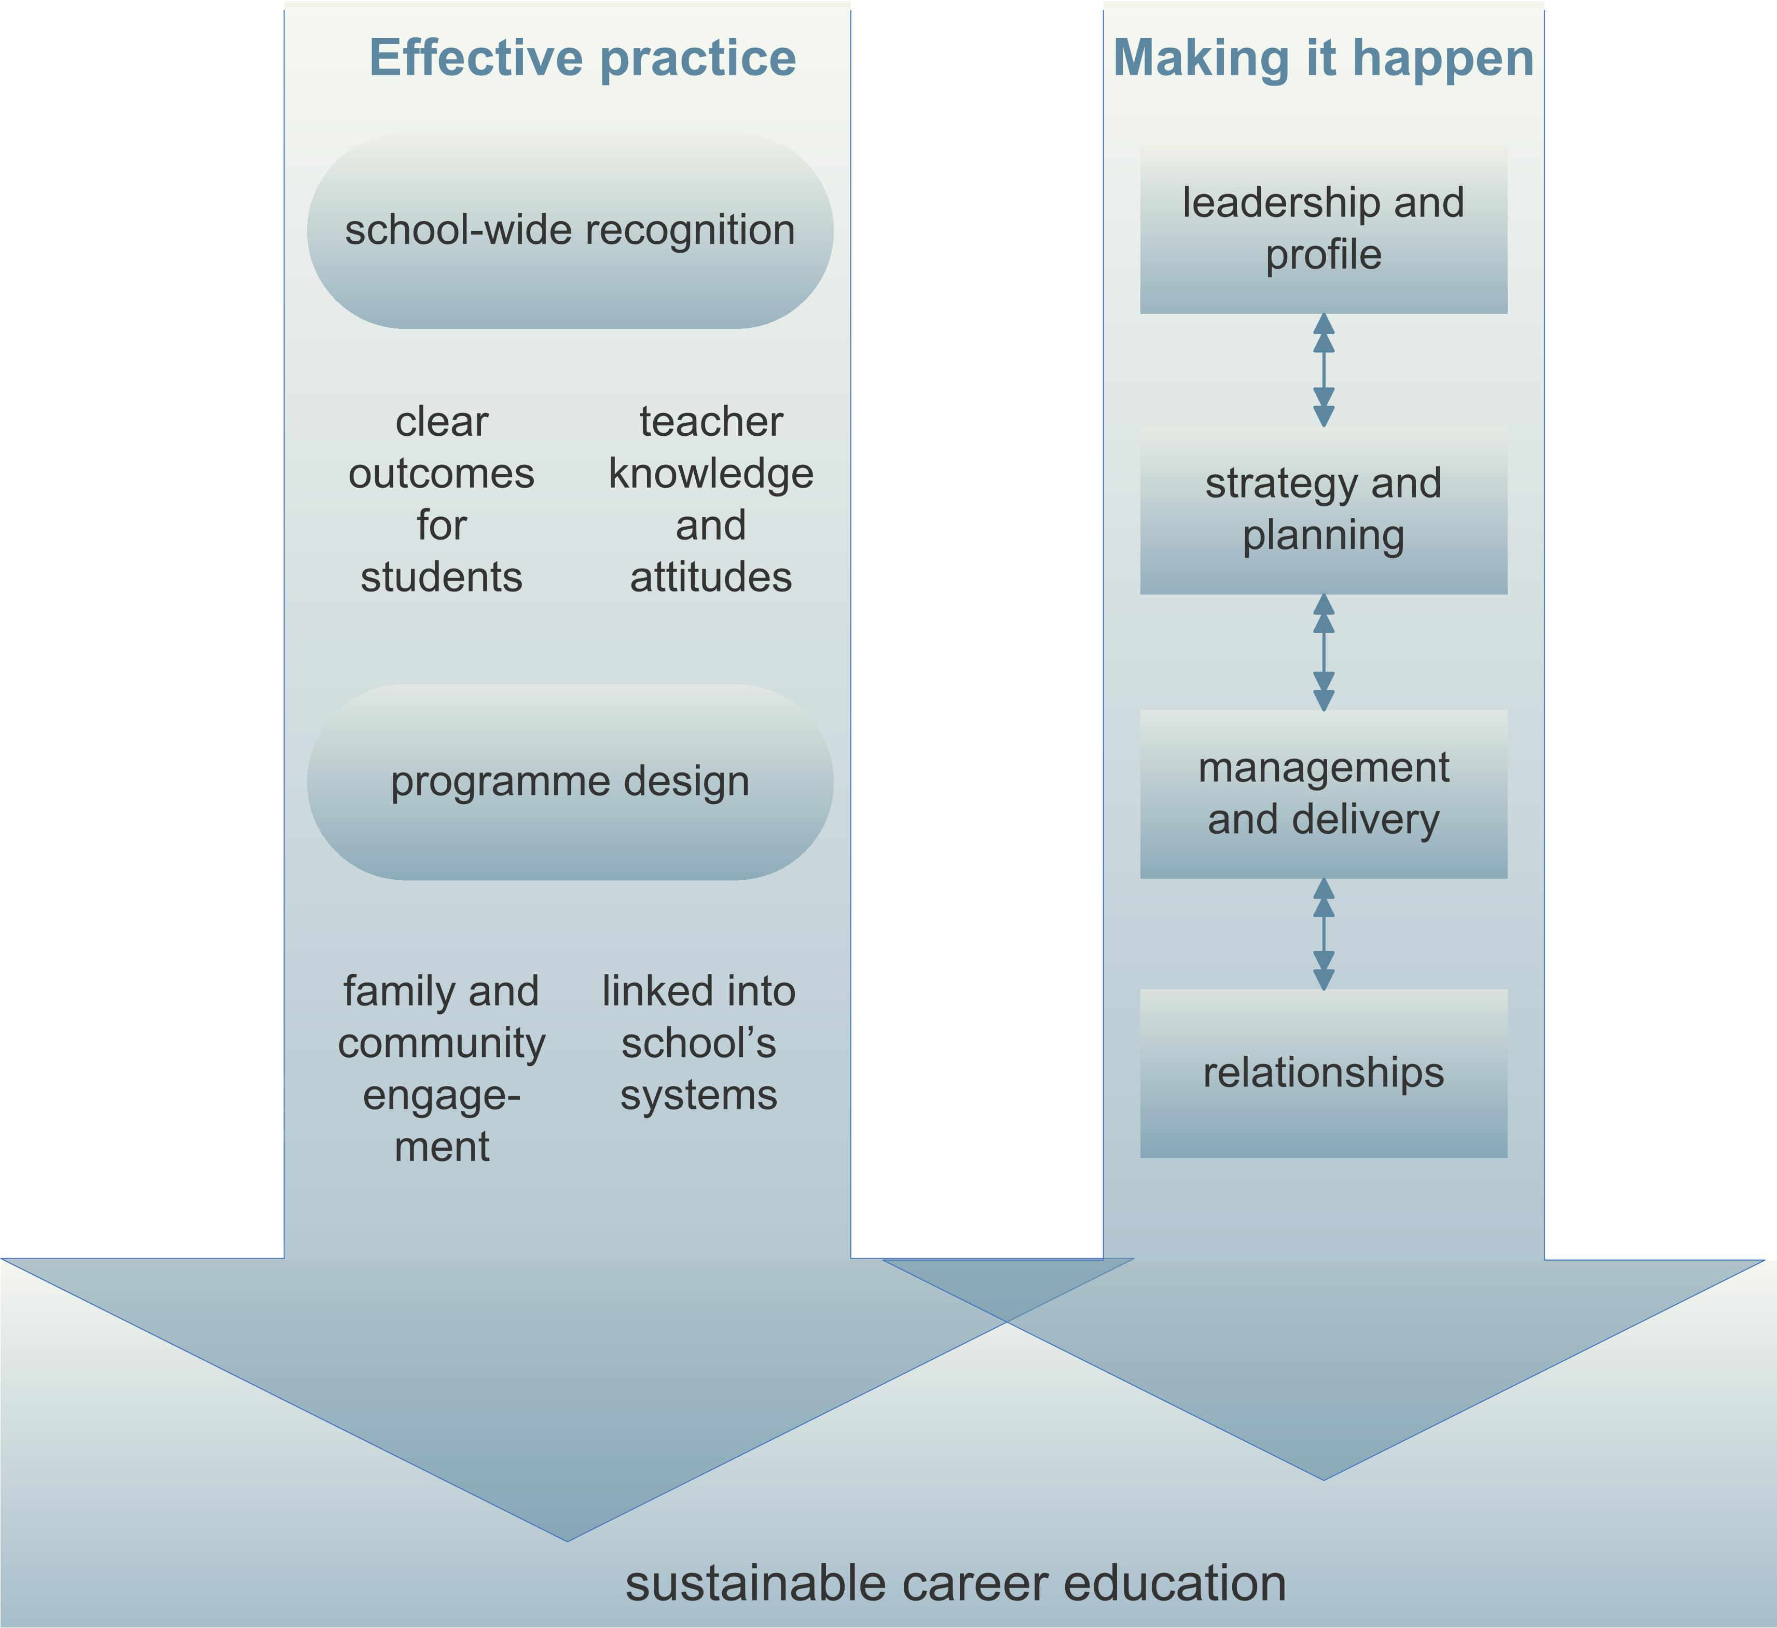
The components of effective practice in this diagram reflect the findings of evaluations and reviews of career education undertaken by the Education Review Office and published in 2006 (Evaluation of the Designing Careers Pilot, Education Review Office, 2006; The Quality of Career Education and Guidance in Schools, Education Review Office, 2006).
National Administration Guidelines
The role of career education in schools is set out in the National Administration Guidelines (NAG 1.vi). This requires schools to
‘provide appropriate career education and guidance for all students in year 7 and above, with a particular emphasis on specific career guidance for those students who have been identified by the school as being at risk of leaving school unprepared for the transition to the workplace or further education/training.’

What should we be able to demonstrate at years 7 and 8?
- We are clear about how NAG 1.vi should be implemented and there is clear direction and policy from our board of trustees.
- We have written objectives and implementation plans for meeting the requirements of NAG 1.vi.
- Our career education provision is based on the Ministry of Education expectation that schools will encourage all years 7 and 8 staff to make a contribution to integrating career education into everyday learning.
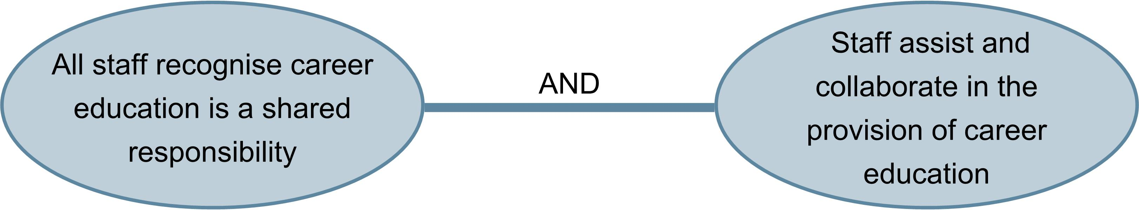
In years 1 to 8 schools, the NAG requires teachers to integrate career education at year 7 and above, but where appropriate, preparatory work that contributes to the skills and understandings of career education can be started at the earliest levels of these schools. The publication Career Education and Guidance in New Zealand Schools (Ministry of Education, 2003, online at www.minedu.govt.nz) includes suggested learning outcomes for years 1 to 6 to assist schools with developing a whole school programme.
In years 7 to 13 schools, years 7 and 8 teachers are able to see the provision of career education at the higher year levels. Building networks within the school and collaborating on planning will help in developing a programme that provides an appropriate foundation and progression towards career education at the higher year levels.
Career education at years 7 and 8 is a curriculum approach which has a conscious focus on preparing the foundations of students’ future career management knowledge and skills.
Leadership and profile
Career education will be more effective when the principal demonstrates commitment, and staff, senior management and the board of trustees work collaboratively.
Indicators of effective practice
→Our school demonstrates a commitment to career education activities and reports on it to the board
→Our teachers understand and promote the importance of career education
→Our school fosters a culture that values all pathways, occupations and aspirations
→We are expanding our knowledge of effective practice in career education
→We are communicating our activities and highlights to our principal and school community
→Our students are actively involved in career education and are well prepared for transition to year 9.
→Other:

Career education leadership involves planning and co-ordinating your school’s career education activities, monitoring and evaluating these activities, reporting outcomes to senior management, and building the presence, profile and understanding of career education across the school community.
While the principal of the school provides the vision and motivating influence, wherever possible, career education leadership should be shared by a small ‘lead’ team.

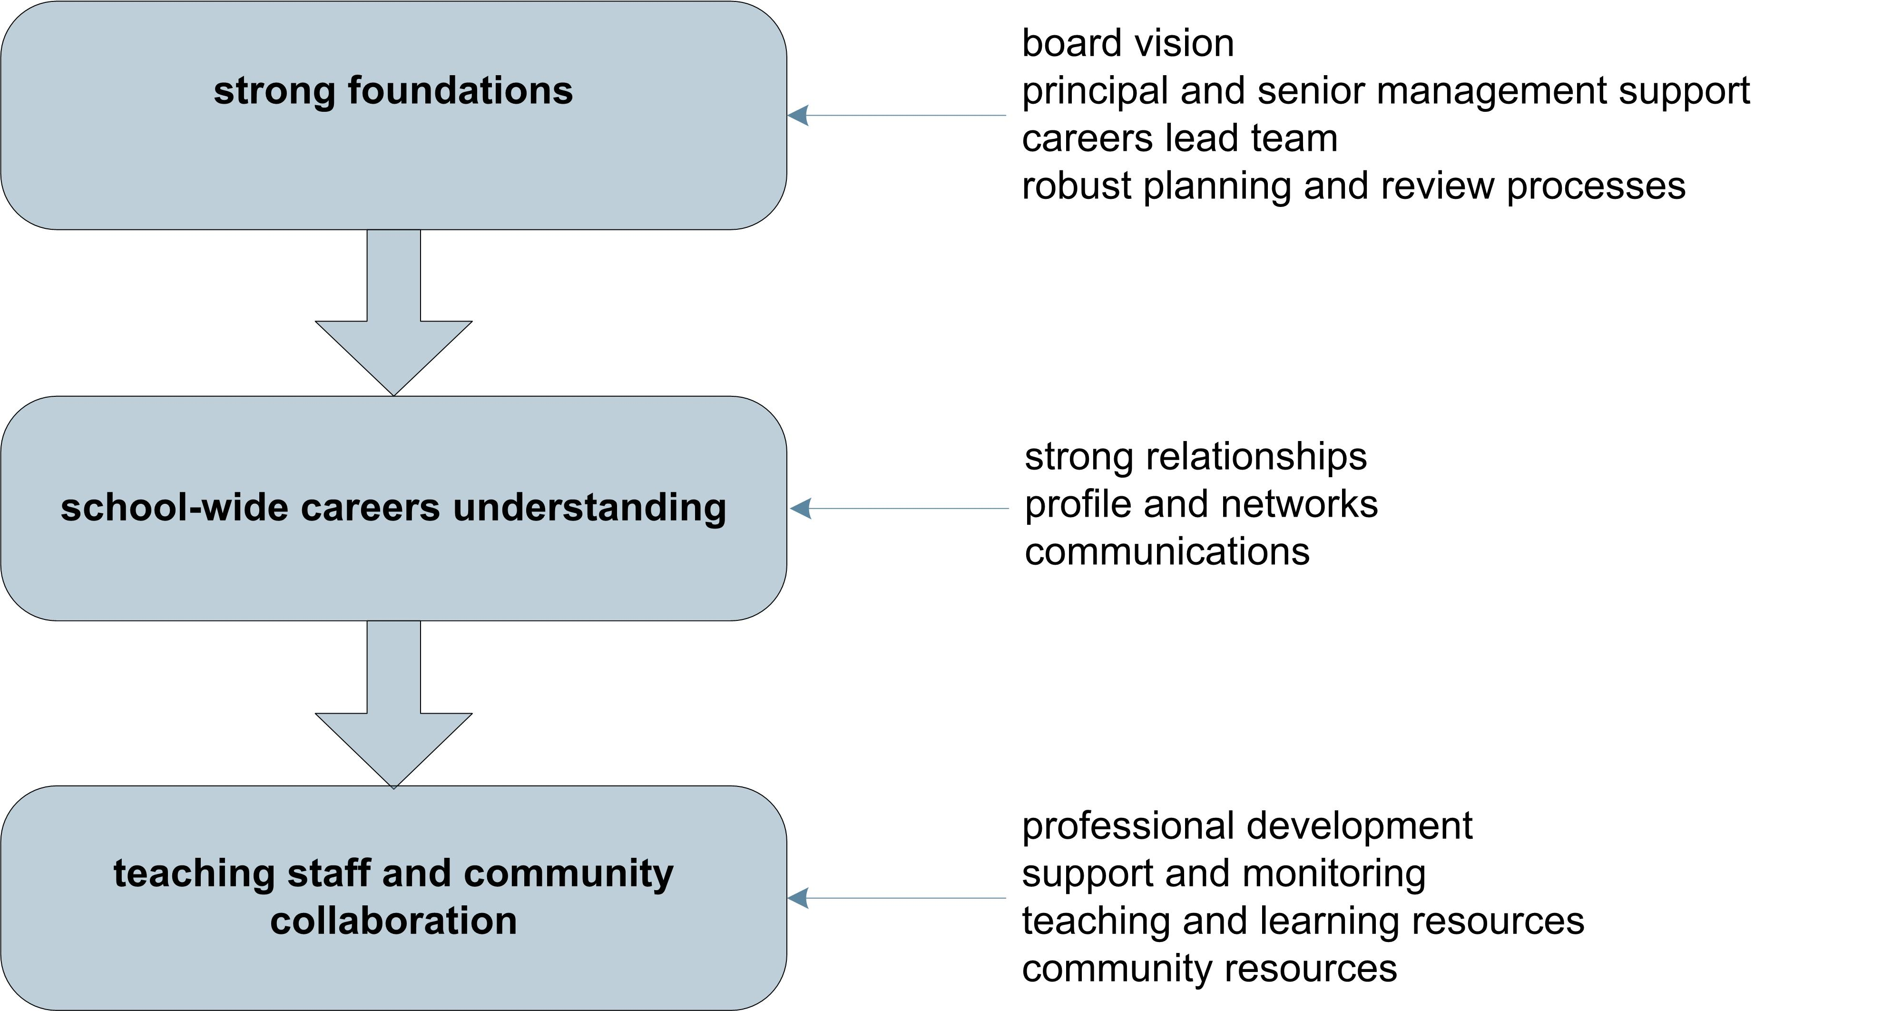
Building a lead team
Career education at years 7 and 8 is a school-wide responsibility. Engaging the wider school in strategy and planning through a careers lead team helps to broaden understanding and awareness of the concept of career education and its contribution to student outcomes.
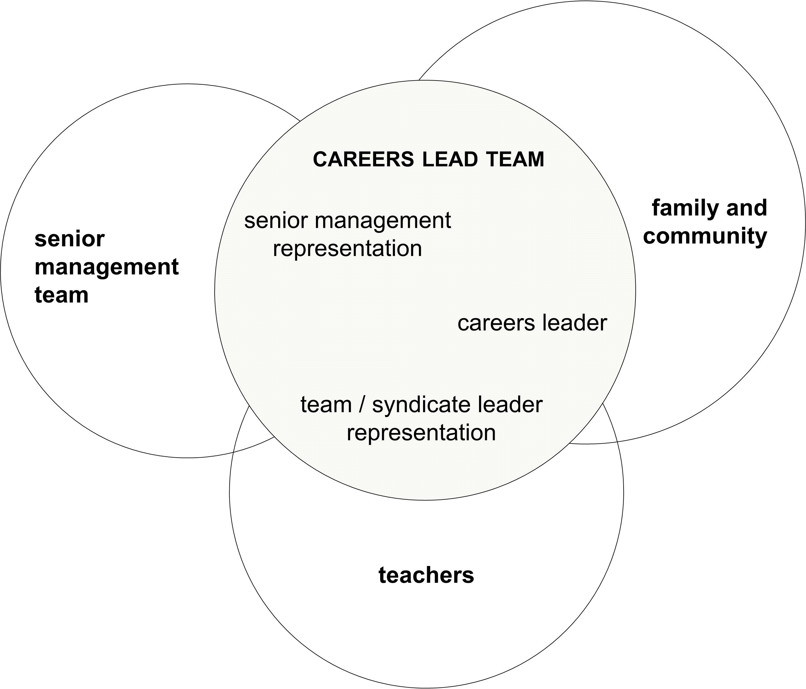
The size of the leadership role depends on the diversity of your school culture, the degree of systematic integration into your programmes, and the level of commitment of other staff. While initially the role may appear daunting, it is useful to think carefully about how much you are already doing. You are likely to find you have a solid base to build from!

Establishing networks within the school (Kaikorai Valley College)
Kate, a year 7 teacher at Kaikorai Valley College, attended a workshop on effective practice in careers education for years 7 & 8 students. She came away from the seminar with greater clarity about career education, an understanding of how it could be added more specifically to school plans in a simple and time-effective way, and ideas about how she could incorporate it into her own teaching practice.
Immediately following the seminar she met with her syndicate leader to update him and he has subsequently arranged the opportunity for her to provide the same information at a years 7 and 8 syndicate meeting. Kate plans to present what she learnt at the workshop and reassure teachers that career education can be integrated into their planning and delivery in a simple and manageable way. The outcome of this meeting will be to formalise steps to integrate career education into the syndicate’s planning process and into teachers’ plans. She also talked to the careers adviser and a senior manager, who both responded positively to her information. Kate now looks forward to being part of a wider school network of career education delivery.

Building the profile of career education
The profile of career education in your school is a good indicator of how well you are communicating the importance of career education.

Here are some suggested ways to raise the profile of career education:
- schedule discussions at board of trustees meetings on the aims of career education at years 7 and 8, future work issues facing the community and your students, and ways of finding and utilising community resources
- consistently present career information in school events
- use past students as role models of success
- make posters of teachers’ own career stories or those of past students for the walls
- place good news stories in school newsletters, magazines and websites
- ask local newspapers to do stories on successful experiences of community involvement
- let parents and caregivers know about things they can do with their children (eg. conversations about work and their children’s strengths)
- involve families and community in activities and let them know how they are helping with career education
- communicate the aspirations of your students to families through student portfolios, taonga files or similar; and include learning goals as part of report evenings.
Strategy and planning
Career education should be systematically planned at all levels and designed around clear outcomes for students. It should incorporate a wide variety of pedagogical approaches to meet students’ needs and draw on resources beyond the school. (ERO, 2006)
Indicators of effective practice
→Career education is included in whole school planning processes and documents
→Career education is planned by a team that includes senior management
→Our planning identifies the needs of our students and of specific groups of students in our school
→We are working to a plan for developing career education activities in our school
→We are consulting and informing the school and local community as part of our planning processes
→We are regularly evaluating and reviewing our career education activities
→Other:

Overview of the planning and review process
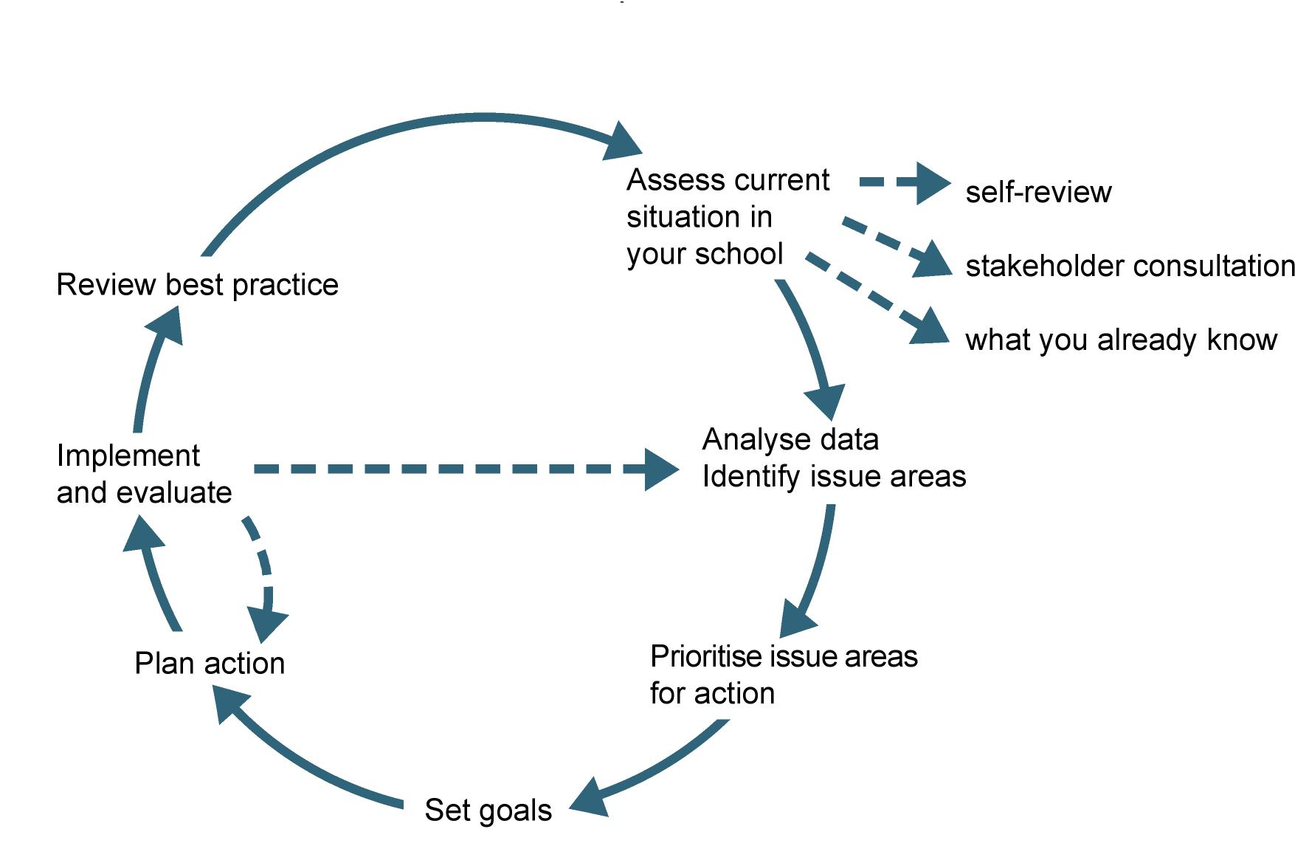
The basis of strategic planning in career education is identifying the needs and characteristics of your students and your local community, and setting clear outcome goals for students. The next step is to prioritise and develop a realistic timetable and approach to achieving these goals.

What do we know about our students?
- What are the characteristics of our students: ethnic mix, socio-economic spread, world view?
- What are the academic abilities and specific learning needs of our students?
- What community groups and extra-curricula activities are they involved with (eg. churches, sports)?
- What aspirations are valued in this community?
- Do we have strong links to the families and whānau of our students?
- Where do our students transition after our school? What secondary school(s) will they move to?
- What challenges and opportunities does the local community present in providing our students with occupational role models and learning experiences about the working world?
- What exposure do our students have to examples and knowledge of emerging occupations and industries?
- What broad national and global labour market trends will impact on our students’ future education and future employment choices?

What evidence can we gather and use?
- Your school management system will be one key source of information about your students. It will hold data such as ethnicity, special needs, attendance and behaviour, academic progress, and destinations of students when they leave. Find out how your school is analysing this data and whether this analysis is identifying specific needs of specific groups of students within the school.
- Questionnaires and surveys are a useful method of getting the views of staff, students or community members. When designing questionnaires, be very clear about why you are asking each question and how you will use the information. Closed questions (using a response scale) are effective in gathering views on current or proposed options but open questions are necessary to gather ideas about what could be. Keep the questionnaire short and make sure the people you survey represents a good cross-section of the group as a whole.
- Small discussion groups are a useful method for testing the results of surveys and brainstorming solutions.
- Remember, people like to know what their comments have led to. Show them their views count by telling them what changes are being looked at or planned.
Integrating career education into school planning processes (Clinton School)
The process began with the principal requesting a meeting with a Careers New Zealand consultant because she was concerned over the small range of careers represented in the local farming community and the limited opportunities for students to develop a rounded appreciation of careers from their everyday experience. Their discussion led to the Careers New Zealand consultant returning to the school to introduce career education at a staff meeting. Staff then began to work on integrating career education into current units. A year later, current units (see example on page 32) include a career education focus and opportunities for students.
Career education is now embedded into planning and the next step is to move it into the strategic level. In the school’s planning for 2009, career education will be incorporated into the next tier of documentation through the key competencies (eg. managing self and relating to others). This will ensure that it becomes embedded in the culture, expectations and practice of the school.
The principal has also begun a process to prepare and involve the board of trustees. The next board meeting will look at ‘The new curriculum: What skills do our children need for the future? What careers are likely for our children?’, and include a presentation of career education resources.
To solve the initial problem – the lack of career diversity in the area for students to observe and learn from – the principal is investigating using online communities to establish links with careers that could be made available for students’ learning.

“At that stage we were in the process of developing mechanisms for the new curriculum and we were able to deliberately link career education into our planning. The key principle was to have all staff take responsibility for exposing students to careers. It became a whole school requirement.”

Management and delivery
Career education is likely to be effective when there is a documented, whole school programme that is integrated into the curriculum in appropriate ways.
Indicators of effective practice
→All staff make a contribution to achieving career education outcomes
→We plan and time our activities to assist students to prepare for transitions (eg. to secondary school)
→We provide opportunities for all students to develop the relevant career competencies
→There are a range of different kinds of learning experiences
→We make appropriate use of outside resources and experiences
→We encourage family and community involvement in appropriate career related activities
→Other:

One important step in managing career education in your school is to have up-to-date documentation that sets out your policies and procedures for delivering career education.
Your school will have a standard approach to documentation – make sure you know what the requirements are and when you need to complete this and other documents, such as reports to the board of trustees. If you want advice on developing your career education management documentation, Careers New Zealand can help.
Things you may include in a career education policy and procedures document are:
- aims of career education in your school (in the context of your school’s mission, vision and aims)
- accountability structures (who is responsible for what), reporting requirements (including key dates and annual budget
- date policies and procedures were last reviewed and approved, and proposed date for next review
- planning, evaluation and review procedures (what, how, when, who)
- overview of how career education is integrated into your programmes
- overview of strategies for specific groups (eg. Māori, Pasifika, migrants, transitioning students)
- a process for recording students’ aspirations (eg. profiles, and how these are used)
- ways information is disseminated to families and community (eg. events, newsletters, website)
- examples of documentation (eg. forms and templates used).
Managing a whole school programme
This includes asking and answering questions like:
- What monitoring will we need to do to ensure quality across all activities?
- How will we gather and synthesise evidence of learning across all activities?
- How much and what kind of support will teachers need from the lead team (eg. preparing lesson plans and teaching resources) and how can we efficiently deliver it (eg. staff meetings, individual).
- How much professional development will staff need? How will this be funded? Who will deliver it? What is available externally?
- Who in the wider community has industry experience that we can utilise?
- Where will we use external specialists (eg. career workshops for parents)?

Maintaining a career calendar
This could include recording dates/due dates for such as:
- community events that would contribute to career education, or may be inspirational (eg. Youth Skills NZ, World of Wearable Art)
- professional development workshops
- preparing communications to staff or parents.
Note: career expos are not seen as appropriate at this level as they are strongly directed towards assisting with career decision making.

Designing activities
Career education is integrated into the curriculum and existing classroom practice through:
connected learning | making explicit links between school learning and world of work knowledge
contextualised learning | activities that reflect the real world of work
experiential learning | activities that involve the real world of work
career foundations | activities that develop key competencies and transferable skills for future career management

“Inquiry learning models offer exceptional opportunities for career education.”
Integrating career education into learning occurs through:
Connected learning … making explicit links between school learning and world of work knowledge
at years 7-8  - skills students are learning, how skills are developed through learning, and how skills  connect to industries and occupations | at years 9-13  - skills students are learning, how to do these well, and industries and occupations where they would be useful to them  - school pathways and tertiary options related to the subjects, industries and occupations
Contextualised learning … activities that reflect the real world of work
at years 7-8  - real-life contexts for projects, simulations, role plays  - learning activities that allow learners to develop aspirations, and recognise their strengths and interests  - guest speakers, professional assistance in the classroom | at years 9-13  - real-life contexts for projects, simulations, role plays  - learning activities that allow learners to focus on, develop and share their individual career aspirations and other interests  - guest speakers, professional assistance in the classroom
Experiential learning … activities that involve the real world of work
at years 7-8  - field trips, external projects, challenges  - community involvement | at years 9-13  - field trips, external projects, challenges  - work exploration and work experience
Career foundations … activities that develop key competencies and transferable skills for future career management
at years 7-8  - feedback, affirming successes, interests, skills, talents and abilities, portfolios  - information-seeking behaviours, study skills, task planning skills  - organising self, follow-up to experiential activities | at years 9-13  - feedback, affirming successes, interests, skills, talents and abilities, portfolios  - information-seeking behaviours, study skills, task planning skills  - subject choice, keeping options open, follow-up to experiential activities
Cafe Quest (Balmacewen Intermediate)
Balmacewen Intermediate provides a curriculum based on rich topics which are investigated through a ten-week inquiry process. One of these rich topics is Cafe Quest. Students plan a ‘cafe for a day’ using the school’s ASPIRE planning process to generate a list of responsibilities and ideas for starting. They identify their ‘smarts’ (their talents and strengths), decide which responsibilities suit them best and create an application for the relevant position. Students who apply for manager or financial adviser positions are selected by interview.
A finance team is set up to oversee budgets and expenditure, a barista is brought in to teach coffee making, a graphic designer comes in to help with advertising posters, and a cafe is organised and set up, providing practical work experience for a day.
Students collate evidence of their research, planning and organisation using graphic organisers, digital pictures and samples of work. After the event they reflect on their contribution to the class cafe and evaluate their success through self and group assessment and in a personal learning story.
The unit provides opportunities to learn business planning, hospitality and world of work skills as well as gain knowledge about specific careers. Upon reflection, the school felt that while they were providing authentic experiences for students and exposure to work and career experiences, they realised that this was not made explicit in the planning or delivery of the unit.
Enhancements are planned for the Cafe Quest unit for this year to make the career education learning outcomes more explicit. This will include explaining and supporting appropriate career learning tasks in the unit planning meeting. This includes students using the Careers New Zealand website to research jobs related to the unit and to help them make links to themselves, such as what jobs in the cafe they like and what skills attract them.

Wearable Art (Kaikorai Valley College)
In her classroom Kate has been working with students preparing for the Wearable Arts show. Her students develop ideas, investigate the design process and create designs and costumes. In past years she has invited students from previous years to speak to the students. This year she is actively seeking to enhance the career education opportunities: she has discussed with students the skills they are learning and how they might be useful in a range of design careers; plans to ask a local designer to come in and talk specifically about her career in design; and is looking at taking the students to the local polytechnic to meet fashion design students and experience their learning environment.
Primary enterprise programme (Tamatea Intermediate)
For two weeks each year, the school is shut down and a new society is set up with government, law and order, and finance systems under the eye of a Governor General (the Deputy Principal). The systems are explained to students through invited representatives to the school, or children may visit the courts, for example, to learn more about the judicial system.
A number of ventures are set up in areas such as marketing, manufacturing, couriers and warehousing. Jobs in these ventures are advertised through a job fair or newspapers and students write ‘CVs’ to apply for the positions they want. The CV is an exercise promoting self-knowledge –students must describe their interests, their personal qualities, their learning and working styles, and their thinking style. Referees’ remarks are also required.
When venture groups are established a work contract is written and the tasks are decided and planned. One group operating as a smoothie making and pizza company organised itself to investigate new flavours, trial and survey their market, produce, advertise, and sell their product. Real budgets are used with real money spent and accounted for.
There are many opportunities for understanding real world tasks and roles, learning about cooperation, contribution and productivity, and finding out more about oneself. For example:
- reflection on ‘what I have learned about myself’ and ‘what I have learned about others’ is part of the end of programme assessment.
- more able students can set up their own ventures and explore entrepreneurship. They employ others by selecting a team from CVs and develop and sell a product.
- students who wish to learn more can gain a Business Diploma in a range of options including marketing, customer relations, tool skills, and citizenship. This isn’t compulsory but it acts as an incentive for those who wish to gain more from the experience.
- real work issues and problems are grappled with – lazy workers, stolen money, uneven effort are part of the experience. One past student applied for ‘government’ funds to set up a mediation service to resolve issues before they came before the judicial process.

“It may involve just one more question in the study, or one more activity, to make the link to career education. For example, when the students are considering ‘who can help us’ as part of their enquiry, it can expand into questions about their jobs, and not just what they do, but why they chose them?”
Relationships
Engaging students, their families, the school and local community is essential for the effectiveness of career education programmes.
Indicators of effective practice
→We encourage our students to engage in aspirational talk and thinking
→We know what career ideas interest our students and help them explore them
→We have links with the secondary school(s) in our community to support effective transitions
→We know what aspirations and expectations families and whānau have for their children
→We encourage families and whānau to participate in career education activities
→We work with the local community to enhance career education activities
→Other:

Engaging school management
To gain and grow support for career education in your school, the careers lead team needs to provide the principal, the senior management team and the board of trustees with relevant information about the objectives and outcomes of the career education programme. This could include:
- the benefits of career education to your students and your school
- how career education in your school is meeting the needs of students (overall and for specific groups of students) and the requirements of NAG 1.vi
- overview of current integration into teaching and learning programmes and future development
- future goals, emerging issues and challenges for your school
- student participation in career education activities and good news stories
- staff professional development.

Engaging teachers
Building teacher knowledge and commitment to career education relies on making sure that teachers fully understand the aims and limits of career education at this level; that they are setting in place foundation understandings and preparatory skills that transfer to the career management skills required for their future. This involves:
- building a whole school understanding of career education at this level
- sharing the goals and outcomes of career education in your school
- identifying and sharing practice that improves students’ achievement
- highlighting the links between career education goals and outcomes and key competencies
- helping teachers to integrate career education into their planning and classroom delivery
- modelling or co-teaching some career education activities.

Engaging students
Students benefit from career education which broadens their understanding of the world of work and helps them build connections between people’s learning, abilities and interests and the careers they choose. Student engagement increases with:
- recognising their own strengths and how they link with their futures
- opportunities to share and talk about their developing aspirations
- enjoyable learning experiences that include exposure to real people and real situations
- opportunities to hear from other young people about their experiences; inspirational role models
- developing an understanding of the meaning of ‘career’ and its applicability to everyone.

Engaging Māori and Pasifika students
Māori and Pasifika students will be engaged when they see connections between their own cultural experience and workplace success.
Research by Aatea Consultants (2005) finds that Māori students see positive relationships as very important to engagement in career education and want to hear about the experiences and successes of others, especially Māori role models, rather than see it in a book or CD.
Consider ways you can ensure a range of skills and talents are represented in the school’s career education activities by including:
- Māori guest speakers who represent and can illustrate a Māori potential approach – that being Māori is an asset to their careers or that being bilingual is a career asset
- Pasifika guest speakers who illustrate ways in which their cultural knowledge and understanding or language supports their working role
- Māori and Pasifika ‘stay in school’ role models – year 13 students who visit, talk about the future careers they plan and how they managed to achieve their school goals to get to this point
- Māori and Pasifika community success stories
- appropriate Māori and Pasifika events that help encourage self-belief and aspirations.
Engaging families and community
Parents and whānau are a key influence on the development of aspirations, educational achievement, and future decision making. They give their children general advice about how to do well in life as well as ideas from their own learning and career experiences.
Schools and their communities work together in a variety of ways to enhance career education opportunities for students. Employers, small businesses, extended family and friends are invaluable resources for activities. The key to maintaining their support is to acknowledge what they do for students and celebrate the difference that it makes.
Ways of engaging families and community include:
- developing a database of family members’ occupations, skills and knowledge, and their willingness to share this with your students
- providing information about career education as part of parents’ evenings and school events, and in school newsletters, orientation packs, etc
- inviting family members into the school to take part in career education activities
- inviting helpers to school celebrations where students show their work
- organising features in the local media that describe their role in student activities.

“This school runs on relationships”
Extract from careers education policy: (Flaxmere Primary School)
Promote home-school partnership and involve the local and wider community in career education:
- continue parent involvement in teaching Māori and Pasifika traditional skills
- encourage and promote whānau support
- invite fathers to school to read to the children, talk about work and its importance
- invite whānau members with work skills and knowledge to contribute to units of study
- build up a database of community occupations and work skills and knowledge
- utilise the knowledge and strengths and interests of the wider community
- arrange visitors and experts to talk to and work with children; talk about the good and bad parts of their work, the tasks and the skills required, the use of equipment and tools, the problems they have to resolve (eg. police and fire officers, dog control, musicians, crafts people, librarian, pool manager, school caretaker, etc.)

Healthy eating (Clinton School)
The staff of Clinton School planned an integrated unit with a theme of healthy eating and established linkages in their planning templates with the careers that the students could be exposed to in that study. The unit required the students to research food types, nutritional values and food preparation styles and their relationship to growth and health. A professional rugby player came into the school to talk about diet and health and the importance of these to his career. At the same time he discussed his career and his paths in the future. A dietician was invited in to help the students and she was interviewed about food, nutrition and food preparation styles.
Part of the unit involved a task to change the Friday menu provided to the school so that it included more healthy food options. The class had to devise new hot lunch menu items that met the criteria for healthy food. The current providers of the school food items, a dairy/cafe owner and the local publican, were invited into the school and interviewed by class representatives about their requirements for supplying food and profitability factors.
Students found that they needed to gather evidence to convince the food suppliers that if new healthy eating options were provided they would be bought by the students. A chef was invited into the school to help with the preparation of samples, such as soup and sushi, and in the process modelled chefs’ skills and ways of preparing food in a hygienic manner. After sampling the new products, other students in the school were surveyed for their opinions on the choices and recommendations were made for new menu items.
The new menu was negotiated with the food suppliers and introduced. Alongside this process, students visited a local organic farm to meet people who supply seasonal and regional farmers markets. Through this visit they were introduced to alternative opportunities in commercial farming and were able to investigate how farming practices affect the quality of the food we eat.
The unit provided the students with knowledge of the work, skills and abilities of people in a range of careers. Students reported on the speakers and the visits; they also reflected on their own roles in the process and on what they did best: whether they were better at making the food, working behind the scenes, acting as negotiators or handling the money and managing the project budget.
Planned enhancements for future units to provide broader career understandings include asking invited speakers to provide more in-depth information about their careers and to answer specific questions, such as Why did you choose that? How did you get into that work?; and asking students to reflect more on their personal attitudes to the careers they saw, the skills involved and their interest in them.
The school recognised the help of the people and families involved in this unit with a celebratory picnic lunch, highlighting healthy eating, which took place part way through the unit. The school also acknowledged their help in the district and community newsletters.

Getting started: for new careers leaders
If you have just taken on a role of careers leader in your school and are unsure where to begin, here are some ideas on getting started. Remember: start where you need to start and take small steps.

Orientation
Framework
- read the Ministry of Education publication Career Education and Guidance in New Zealand Schools. This is an online publication. You can view it or download it at http://nzcurriculum.tki.org.nz/Careers
- locate your school’s management and related documentation for career education. This may include your school’s policy or charter, career education planning documentation, recent ERO reports, delivery plans.
Role
- discuss with the principal the board’s and school management team’s vision for career education at your school
- clarify with the principal the exact nature of your role and responsibilities and what structures (eg. careers lead team) there are or will be to support implementation of career education across the school
- identify the key contacts for career education in your school. It may be syndicate leaders; in a years 7-13 school, it may include the careers adviser
- contact your local Careers New Zealand office (0800 222 733) to make a time to meet with a consultant who will be able to provide professional support and advice.
Professional knowledge
- read this guide and Career Education and Guidance in New Zealand Schools (see above) so you are clear about:
- what career education is
- what skills and understandings people need to develop for lifelong career management
- what learning outcomes are appropriate for students in years 7 and 8
- how career education at years 7 and 8 builds foundations for years 9 to 13 students
- how career education links to the key competencies in the New Zealand curriculum
- how career education can be integrated into classroom teaching.
- identify appropriate career education resources for years 7 and 8 and become familiar with these
- get to know the Careers New Zealand website (www.careers.govt.nz).
Preparation
You may decide to do some or all of these activities and sequence them as best fits your situation.
- organise and deliver a short professional development session with all staff to explain your role and begin the process of engaging the whole school. You need to:
- get the active involvement of your principal and school management team in the session
- provide an overview of career education and clearly link it to your school’s goals and strategies
- consider using a questionnaire to help you identify staff who have experience and/or interest they can contribute to planning and implementation of career education
- consult with curriculum and syndicate leaders to explore what career education content is already being included in current learning programmes and potential opportunities for development
- use the checklist of effective practice indicators in Appendix 1 to assess your current position. What is your school doing well? What could you easily improve? What would take more effort?
- meet with the principal or designated member of the school management team to discuss:
- your discussions and conclusions
- the possible composition of a careers lead team (the establishment of which may be the responsibility of the principal or management team member)
- next step actions for your leadership role.

Moving forward
Organise careers lead team meetings to discuss planning and implementation, for example:
- what effective practice is
- what the school is doing now, what is needed next and realistic priorities and timeframes for action
- what support staff will need to deliver career education.
You could invite a Careers New Zealand consultant to be part of this process. They will be able to provide assistance through:
- professional development to enhance staff knowledge and understanding of career education and career resources and reassure them that they are possibly already making the links for students and that all that is needed is to make these links more explicit
- review and design of career education programmes and the desired outcomes for students
- ideas for integrating career content and career resources into learning activities, for helping students make effective transitions, and for engaging whānau and community.

References
- Carpenter, H. (2008) The Career Maze – guiding your children towards a successful future. Auckland: New Holland
- Hill, J. & Hawk, K. (1998) Aiming for Student Achievement: How teachers can understand and better meet the needs of Pacific Island and Maori students. SET 1998. Accessed from www.leadspace.govt.nz, June 2008
- Kabir, N. & Rickards,T. (2006) Students at Risk: can connections make a difference? Youth Studies Australia, December 2006
- Kerka, S. (1994) Vocational Education in the Middle School. ERIC Digest No. 155
- Ministry of Education. (2008) Ka Hikitia: Managing for Success. Māori Education Strategy 2008-2012
- Ministry of Education. (2007) The New Zealand Curriculum, Key Competencies
- Morgan, S., Hutchinson, J. and Crampton, N. (2007) Effective Transitions for Year 8 students. Occasional Paper, Centre for Guidance Studies, University of Derby
- Schultheiss, D.E.P. (2005) Career Development in Middle Childhood: a qualitative inquiry. Career Development Quarterly, March 2005

Leadership and profile | What do we see now? | How to be more effective? | What support is needed?
Our school demonstrates a commitment to career education activities and reports on it to the board
Our teachers understand and promote the importance of career education
Our school fosters a culture that values all pathways, occupations and aspirations
We are expanding our knowledge of effective practice in career education
We are communicating our activities and highlights to our principal and school community
Our students are actively involved in career education and are well prepared for transition to year 9
Other:
Strategy and planning | What do we see now? | How to be more effective? | What support is needed?
Career education is included in whole school planning processes and documents
Career education is planned by a team that includes senior management
Our planning identifies the needs of our students and of specific groups of students in our school
We are working to a plan for developing career education activities in our school
We are consulting and informing the school and local community as part of our planning processes
We are regularly evaluating and reviewing our career education activities
Other:

Management & delivery | What do we see now? | How to be more effective? | What support is needed?
All staff make a contribution to achieving career education outcomes
We plan and time our activities to assist students to prepare for transitions (eg. to secondary school)
We provide opportunities for all students to develop the relevant career competencies
There are a range of different kinds of learning experiences
We make appropriate use of outside resources and experiences
We encourage family and community involvement in appropriate career related activities
Other:

Relationships | What do we see now? | How to be more effective? | What support is needed?
We encourage our students to engage in aspirational talk and thinking
We know what career ideas interest our students and help them explore them
We have links with the secondary school(s) in our community to support effective transitions
We know what aspirations and expectations families and whānau have for their children
We encourage families and whānau to participate in career education activities
We work with the local community to enhance career education activities
Other:

ASPIRE is the school’s own template for implementing inquiry learning: Accumulate, Sort, Plan, Investigate, Report, Evaluate

